Pump Repairs and Upgrades Standards

Vertical Turbines, VPRS, rev. 6

FOREWORD

Pump industry is undergoing renewed interest to technical aspects of quality of repairs. Pump users expectations of good quality of repairs must be matched by a well defined set of specifications, to clear state the extent and details of a quality repair job. The first such specification draft has been published by a working Advisory Committee group of the Pump Magazine. Users, manufacturers, and repair shop facilities' input is encouraged, to provide inclusive and rounded basis for the final document to serve pumping industry needs in quality repairs and overhauls of pumps.

This idea behind this specification is to combine and blend together two needs. The first is essentially a need for a simple and factual list of specific data, tabulations and charts, with recommendations for a typical maintenance department on what is to be done with the pump. This provides information and recommendations on inspection and replacement of parts, to ensure clearances, tolerances, and other dimensions are in conformance with best industrial practices and latest technologies to ensure long life in terms of reliability and efficiency of the to-be-rebuilt equipment. The second need has always been for a tutorial to help practicing plants’ maintenance and engineering professionals learn and understand the reasons behind numbers and recommended values when considering pump repairs. The VPRS spec thus evolved from the recommendations provided by the VPRS Advisory Committee, as well as by many pump users interested in helping develop this document into a on-the-shelf reference document to assist in both quick look up guide on recommended parameters as well as some sense of cost estimate for those who need a simple but specific set of recommendations and data, as well as a useful learning information manual with material available for educational and reference purposes. Plant engineers, maintenance managers, interested to enhance their knowledge with latest techniques, technologies and methods available to them will find this documents helpful from in both aspects.

The VPRS continually undergoes periodical revisions and updates, as new information, feedback from the field, end users, OEM pump and motor manufacturers, repair facilities is received. Advisory Committee monitors and guides this process and appreciates any comments, suggestions, enhancements, and corrections to any inadvertent errors that may need to be reviewed and corrected. For information and suggestions contact the Advisory Committee members listed at the in the committee section.

Dr. Lev Nelik, P.E., Pumping Machinery, LLC, VPRS Committee Chair
February 12, 2014

VPRS Committee Members

USA:
* Doug Davidson, PumpTech, Inc.
* Lori Ditoro, Pumps & Systems magazine, US - publications/media
* Rasmus Dorrington, Colonial Pipeline, US - pump end users
* Mike Keohane, VibrAlign, US – alignment and vibrations
* Ed Kreibick, DuPont, US - pump end users
* Chris Krpec, Sulzer Pumps - pump manufacturer (OEM)
* Bill Kruger, All-Test Pro, LLC (wholly owned Subsidiary of BJM Corporation) - testing
* Dick Lane, Maintech International, Inc - repairs
* Lyle Mariam, Las Vegas Valley Water District (LVVWD) - pump end users
* Dave Lyle, Nidec Motor Corporation (includes US Motors) - motors and other drives
* Lev Nelik, Pumping Machinery, LLC, Committee Chair
* Bethany Pearson, P.E., Burns & McDonnell, consulting engineering
* Luis Rizo, P.E., Sabic International - pump end users, documentation
* John Stevens, Jacobs Engineering - consulting engineering
* David Tuck, Greenwood South Carolina Municipality
* John Visotsky, Vibrations Institute, Georgia section
* Eben Walker, Graphalloy Graphite Metallizing - components and materials
* Dave Werth, Clemson Engineering Hydraulics – pump inlet and sump issues
* Adam Willwerth, Electro-Static Technology-ITW
* Bud Young, Jacobs Engineering - consulting engineering

International:
* Aditya Pathak, Technimont ICB Pvt Ltd (India) - machinery and system packages
* Michael Benjamin, Mekorot Waterworks (Israel) - pump end users
* Jeoff Eichert, Fluculant Systems (Germany) - pump end users
* Huseyin Gokcekus, Cyprus Research (Cyprus) - engineering applications and design
* Chaza Hamoud, Beirut Arab University (Lebanon) - consulting and academia

(for those interested to be on this committee: drpump@pumpingmachinery.com)

TABLE OF CONTENTS

Foreword
Introduction
1. Vertical Pump Types and Construction
2. Documentation and Repair Forms
3. Predictive and Proactive Maintenance and Trending Monitoring Techniques
4. Vibration Analysis
5. Foundation, Baseplates, Piping, and Supports
6. Field Work, Tools, and Site Access
7. Suction Issues
8. Mechanical Seals and Packings
9. Materials of Construction
10. Motors, VFD, and Electrical Aspects
11. References and Bibliography

INTRODUCTION

The intent of the current specification is to apply it mainly to large vertical turbine pumps, with power level over 500 hp or and/or bowl sizes over 12”. As discussed in the body of the document, there are essentially three levels of repair that may apply to a vertical turbine pump. Ideally, not only all worn parts need to be simply replaced, but the final stack up of tolerances must be such that the entire rotating assembly is properly centered within the stationary components of the pump, as well as proper alignment to the driver. Excessive eccentricity (lack of proper concentricity) between mating parts could be even more problematic than incorrect clearance. For example, if a clearance between the impeller wear ring and casing wear ring is 0.020” instead of maximum allowed 0.016”, more leakage will result in decrease in flow and efficiency, but may not result in immediate or quick failure, while a 0.005” allowed concentricity made instead to be 0.020” between the shaft and a guide bushing could result in actual contact between these parts, with possible catastrophic, and quick, failure consequences.

For lower power level smaller pumps, the unfortunate present practice by most repair facilities is primarily to replace worn parts, paint the pump and deliver it back to site. The effort and expense to measure and restore eccentricities is rarely done, mainly due to most repair facilities handling small pumps lacking proper machinery to restore eccentricities, which is also perceived as unnecessarily expense. As a result, a small pump may again wear out too soon, will vibrate, gets removed and repeatedly repaired, often after 3-5 years, instead of potentially operate well into 15-20 years time which is not unreasonable (depending of course on application specifics, such as abrasive sand, etc.)

For larger pumps, however, a much more thorough examination, documentation, and restoration of internal concentricities must be, and usually is, done, as such added investment in cost is often (although unfortunately still not always) seen as justified in a long term view, given a relatively smaller proportion of such added expenses versus simply replacement of worn components. Quality concienceouos end users take time to prepare detailed specifications on repair process, with much greater attention to technical details. A team reviewing the project would involve maintenance, operators, engineering, and procurement people.

For example, a large 48” vertical pump may cost $100,000 to rebuild it properly, of which restoration of eccentricities portion of the cost might be approximately $10,000, i.e. 10%. For a smaller (6” pump), a total cost without restoration of eccentricities could be approximately $10,000, and restoration of eccentricities could be around $5000, which is 50% of the cost. When competitive bids are considered, the seemingly high proportion of an added 50% cost would usually be considered an unneeded option by the purchasing, with engineering group rarely being involved or having much say in this process, because small pumps are usually considered not too critical. For larger pumps, on the other hand, engineering group is more likely to be involved, and reliability aspects including total cost of quality, which includes cost of probability of failure, so that such considerations take an elevated priority.

Understanding the impact of eccentricities restoration versus clearances is critical. To manually measure a 48” bowl rabbet fit diameter is not a trivial task. Most small repair shops do not have large and expensive calipers to measure such diameters, and even when they do, the exact determination of the eccentricities is impossible by using hand-held tools, but requires setting of parts (column, support head, bell) on a large lathe or a vertical milling machine. To determine eccentricity between rabbet (register) fits of opposite ends of the 48” pipe column is impossible without such large lathe, and the time and expenses associated with that typically appears excessive to the end user. In many cases, it is the set up time to install such large column pipe on the machine which may cost 90% of the effort, with the machining time itself taking only the remaining 10%. In other words, once the column pipe, or a bell, or a discharge head is finally installed on the large lathe to measure dimensions (clearances and eccentricities), it is worthwhile to go ahead and take the restoration weld-up and skim cuts at the same time.

For medium size pumps, the approach depends on the end users awareness of the need as described above. Some end users may take a full restoration of eccentricities as a must-do part of the repair process, and others do not. One of the main objectives of VPRS document is to help educate the end users to understand reasons of proper repair and to present cost of quality and consequences of not following it. Understanding the difference between a clearance between parts versus eccentricity between same parts is an important starting point to begin properly understand what a quality repair means, and why it should be performed.
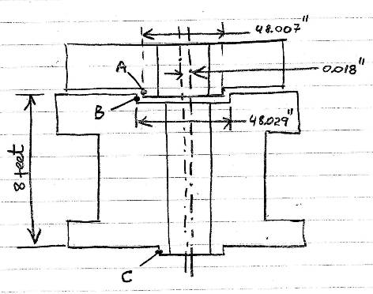
Fig. 1 Clearance versus concentricity (eccentricity) concept

In the above example, there is 48.029 – 48.007 = 0.021” clearance between surfaces A and B, which would be acceptable, if, for example, the allowable max clearance not to exceed 0.025”. However, there is a 0.018” eccentricity between surfaces B and C, which means that once the shaft is inserted thru these parts it would hit the side. Considering the 8 feet length of parts in this example, it would be impossible for a repair shop to measure concentricity without setting the lower part on the machine (such as lathe) and measure concentricity between surfaces B and C by the tool of the lathe, in a single setting without re-chucking, or by machining an additional control surfaces (a “cheater cut”) somewhere along the 8 feel length to establish a concentricity reference plane if the part needs to be re-chucked and flipped.

This standard specifies requirements and guidelines for the evaluation of existing vertically suspended pump installations as well the execution of pump repair and upgrades. For the purpose of this standard, the pump installation includes the pump, driver, electrical system, intake structures, and piping.

As noted, this standard focuses primarily on engineered quality repairs, per Level 3. Levels 1 and 2 are described within the standard mainly for the purpose of general comparison and information for those interested.

This standard does not apply to new pump installations, vertically overhung pump services, and submersible motor type pumps including deep well or hermetically sealed pumps, although some of the concepts and techniques described within it would be found useful and informative for these types as well.

1. Vertical Pump Types and Construction

Vertical pumps come in a variety of configurations and are built to a number of different industry standards, but all are normally placed with the liquid handling end in a sump or well below the level of the discharge piping. The driver is mounted above the pump in a dry location.

The pump suction may be taken from a suction line, normally at the same elevation as the discharge for double casing vertical pumps or from a pit for single casing pumps, as shown on Fig. 1-1:
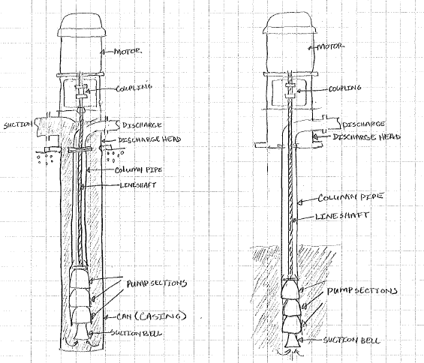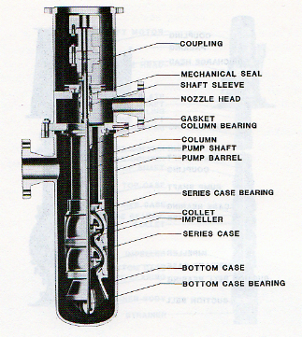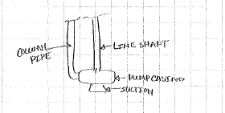
Fig. 1-1 Open shaft versus enclosed shaft concept

Each pump stage discharges up through a column pipe that can either share a centerline with the line shaft or, in the case of a cantilever style, be located to the eccentrically.
Vertical Turbine Pumps (VTP’s) are one of the classifications of the “Wet Pit Pumps” intended to be submerged while in operation. They may also be referred to, in certain industries or applications, as “Deep Well Pumps”. These pumps can be designed to operate at capacities as low as 10 to 15 gpm and as high as 25000 gpm or more, capable of generating heads that can range up to 1000 ft.
Because of their design these pumps are slender and long, making for a top heavy center of gravity when coupled to the motor. This makes them hard to lift and tough to handle. Repairing them requires careful planning and preparation prior to disconnecting and removal from service and careful inspection and repair to assure proper performance and long term reliable life.
The discharge head is typically mounted to a flange that can be mounted to a vessel flange, well, soleplate and foundation, or structural steel

The pumping assembly consists of the suction bell, casing, and impeller assembly. The suction bell may have a spider support or steady bearing to position the shaft and impeller in the casing. In some cases, this is omitted due to inlet hydraulic concerns. Casing styles can be diffuser or volute, and the impeller geometry can include radial or axial entry. The pumps may be single stage or multistage depending on the head and flow requirements. For multistage pumps, intermediate bushings are included between stages.

Impellers are driven via an extended line shaft. The shafts use bushings or fluid film bearings placed along the length of the shaft to provide lateral stability. The bushings and bearings are typically product lubricated, but other lubrication is available in the event the pumped product is not suitable. The line shaft is sealed at the discharge head via packing or mechanical seals. The line shaft is coupled to the driver normally by a solid coupling.

The driver is most commonly an electric motor, but other drivers including diesel engines and steam turbines can be used. For the majority of applications, the driver is positioned on the discharge head with a machined or rabbet, spigot fit or positioned using pins or dowels. For belt driven pumps, the driver may be mounted to the side of the discharge head instead of being mounted in line with the line shaft.

The flexibility in the configuration of vertical pumps allows them to be used across many industries and applications. Vertical pumps are widely used in power generation, municipal water supply and water treatment, oil and gas processing, chemicals production, mining, mill, pulp and paper, foods and consumer products production, and other light industrial services. While widely used for cooling water applications, they are applied to a wide variety of fluids especially where vapor pressure requires more NPSH than what is available at grade or when pumping out of a sump. A sampling of applications includes:

- Cooling water
- Light hydrocarbons
- Cryogenic liquids
- Boiler feed water
- Steam condensate
- Sewage
- Slurry
- Waste paper stock
- Black Liquor
- Food pulp
- Firewater

Because vertical pumps are so versatile, there is a fleet of pumps in the US that require regular monitoring, inspection, service, and repair. In some cases, upgrades can improve the service life, performance, and life time cost of the installation. In other cases, the initial installation of the pumps may not have accounted for design factors that came to light after the pump was put into service. In all cases, regular maintenance and repair is required to keep these vertical pumps in working order. Subsequent sections will detail guidelines and best practices for the planning and execution of the maintenance, repair, and upgrade of these pumps.

Open vs Closed Shaft Design Options:

On close-coupled industrial-type vertical turbine pumps installed in sumps there may not be any intermediate bearings between the discharge head and the top bowl bushing. The manufacturer makes this determination based on the length of the span between those two points, the shaft diameter, the separation from first critical, shaft speed, and other factors. When an intermediate bearing(s) is required, or in the case of a deep-well vertical turbine, there are two basic shaft designs: open line shaft, and enclosed line shaft.

In an open line shaft design the intermediate shaft bearings are lubricated by the pumped liquid. In an enclosed line shaft design the shaft and shaft bearings are enclosed inside a shaft enclosing tube. Lubrication medium (e.g. oil, grease, or clear water) is introduced into this tube at the discharge head.

If the intermediate line shaft bearings in an open line shaft design show abrasive or corrosive wear, consider modifying to an enclosed line shaft design. This is not a difficult field conversion if the correct parts are on hand. Contact the OEM, advising the pump Model and Serial Number, for a priced list of the necessary components for such a conversion.

Investigation into the condition of the shaft needs to take place in order to make a proper repair. Line shaft bearings need to be examined for signs of wear. The shaft needs to be inspected for pitting and stress cracks. On enclosed line shaft designs, the shaft enclosing tube also needs to be examined for wear and erosion.

If wear is excessive it may not be practical to salvage the worn components. A re-evaluation would be recommended to check the compatibility of the pumpage with the shaft/bearing materials as properties of the fluid may have shifted.

Bearings for enclosed line shafts in non-corrosive service are typically bronze with stainless steel shafts. Bearing upgrades are typically performed on open line shaft, product lubricated vertical pumps. For open line shaft vertical pumps:

- Sleeves, shaft bearing journal and bearing ID can be hard-coated
- Sleeves and shaft bearing journal can be bare metal, uncoated
- Sleeves and shaft bearing journal can be hardened metal
- Sleeves and shaft bearing journal can be surface coated or fuse-coated
- Bearings can be
  - Metallic (bronze, cast iron or Nitronic stainless steel)
  - Carbon (with Various fills)
  - Rubber (pop-in or Cutlass/Marine)
  - Other materials, such as glass-filled epoxy, PTFE (polytetrafluoroethylene) or composites/plastics

2. DOCUMENTATION AND REPAIR FORMS

Below is an example of the proper dimensional inspection of a pump, showing the marked-up drawing (or a sketch), along with the referenced detailed tabulation of every clearance and eccentricity in the pump. This information must be included within the detailed report. Note customer comments and requested (noted in read) along the margins:

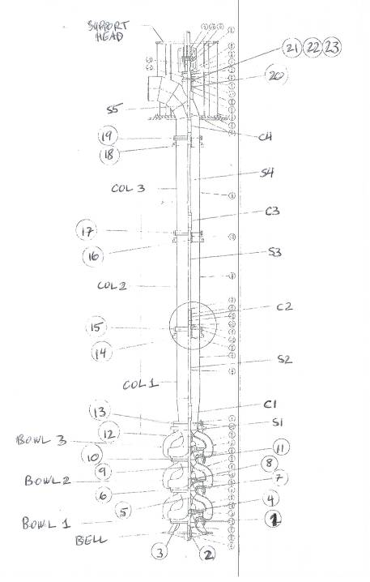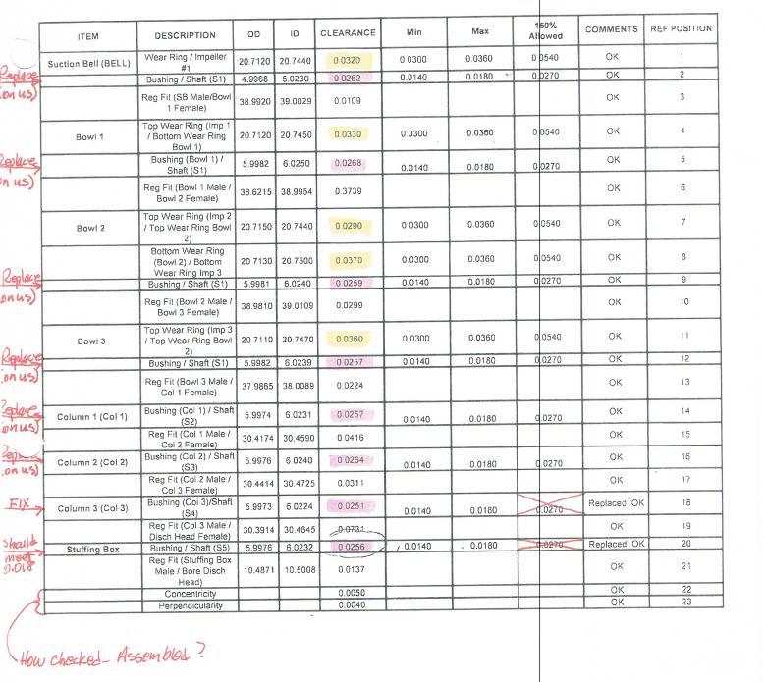
Fig. 2-1 Inspection report must contain detailed information on all internal; clearances and eccentricities

Bushing clearances vary based on the materials and application. Generally the larger the
clearances the more vibration the pumps will experience. The clearance is a tradeoff between
stability, the risk of seizing or galling and the ease of assembly. A good place to start is the
bushing manufacturers’ data. API-610 is another source of recommendations although most
manufacturers recognize that these are very conservative recommendations (larger clearances to
avoid failures).

Shop Inspection checklist of a Typical Vertical Turbine
- The pump is completely disassembled and inspected. Particular attention is focused on unusual wear due to:
  - Improper clearances
  - Corrosion / erosion
  - Flow problems
  - Cavitation
  - Contaminants
- Digital photography should be used to document specific damage for customer inspection.
- All parts need to be cleaned thoroughly and inspected. All abnormal conditions should be noted in the repair sheet (As found conditions)
- Precise measurements are required on all wear components and noted (as found conditions) on the inspection form. Non-destructive testing is performed on all parts.
- Parts should always be replaced with same or upgraded materials per customer/OEM specification.
- Impellers should be dynamically balanced to our customer's/OEM specification.
- The pump should be mechanically and pressure tested prior to completing the repair when performance testing is available.
- Check all runouts (TIR) to insure unit meets all requirements in accordance with fits and clearance guidelines listed below.
- Documentation is needs to be checked for completeness during disassembly, so that the appropriate repairs and new parts can be made by replacement or modifications,
- During reassembly a REPAIR REPORT all measurements documented as left needs to be assembled.
Vertical Turbine Pumps fits and clearance checklist (a more detailed information can be obtained from a pump manufacturer, as it varies with the design, size, and other parameter. However, this tabulation can provide a good general ballpark values to ensure no gross errors in dimensions are made, and could be especially useful for pumps with misplaced, lacking, or unclear information, or obsolete designs):

No: | Measurement | Tolerance
 | Ball bearing inside diameter (I. D.) to shaft. | 0.0001" to 0.0007" (0.003mm to 0.018mm) interference.
 | Ball bearing outside diameter (O. D.) to housing. | 0.0001" to 0.001" (0.003mm to 0.03mm) clearance.
 | Sleeve to shaft. | 0.001" to 0.0015" (0.03mm a 0.04mm) clearance.
 | Impeller to shaft. | Metal to metal fit to 0.0005" (0.13mm) clearance.
 | Shaft | 0.0005 in (.013mm)/ ft (1/3meter) of shaft length but not more than 0.001in (0.003mm) within any 1 ft (1/3meter)
 | Note: there are pumps that are designed to have interference fits between the interconnecting parts. Consult your owner’s | manual and contact the OEM for design details
 | Throat bushing
 | Throat bushing to case. | 0.002" to 0.003" (0.05mm a 0.08mm) interference.
 | Throat bushing to shaft. | 0.015" to 0.020" (0.40 a 0.51mm) clearance.
 | The throat bushings on some vertical in-line pumps act as clearances. | intermediate bearings and require closer.
 | Impeller
 | Impeller ring to hub. | 0.002" to 0.003" (0.05mm a 0.08mm interference.
 | The impeller ring is normally doweled/ spotwelded in | at least two places welded
 | Impeller ring to case ring clearance. | 0.010" to 0.012" (0.254mm a 0.3mm) plus 0.001" (0.03mm )per in. (25.4mm) of impeller ring diameter up to a 12" (3,658mm) ring. Add 0.0005 (0.013mm) per inch (25.4mm) of ring diameter over 12" (3,658mm). For temp. ≥ 500 ° (260οC) add 0.10" (2.54mm). Also add 0.005 (0.127mm) for galling materials (stainless steel).
 | Renew impeller rings when clearance reaches twice original clearance.
 | Case rings
 | Case rings are not to be bored out larger than 3% of original diameter..
 | Case ring to case. | 0.002" to 0.003" (0.05mm a 0.08mm ) interference.
 | The case ring is normally doweled or spot welded in | at least two places.
 | Oil deflector to shaft. | 0.002" to 0.003" (0.05mm a 0.08mm ) clearance. Install "O" ring in the ID if possible.
 | Packing gland
 | Packing gland to shaft. | 1/32" (0.8mm) clearance.
 | Packing gland to stuffing box bore. | 1/64" (0.016mm) clearance.
 | Lantern ring | .
 | Lantern ring to shaft. | 0.015" to 0.020" (0.40mm a 0.51mm) clearance.
 | Lantern ring to stuffing box. | 0.005" to 0.010" (0.13mm a 0.25mm) clearance.
 | Coupling to shaft. | Metal to metal to 0.0005 (0.013mm) clearance.
12 | Seal gland
 | Seal gland alignment boss to stuffing box. | 0.002" to 0.004" (0.05mm a 0.10mm) clearance.
 | Seal gland throttle bushing to shaft. | 0.018" to 0.020" (0.5mm to 0.51mm) clearance, unless otherwise specified for hot pumps.
 | Seal locking collar to shaft. | 0.002" to 0.004" (0.05mm a 0.10mm) clearance
 | Seal spring compression. | 7/8" (22.2mm) long springs - 3/16"(4.8mm).
 | ″ | ¾" (12.5mm) long springs - 5/32"(4.0mm)
 | Seal spring compression. | 1/2"(12.7mm) short springs - 1/16" (1.6mm)unless otherwise specified by the manufacturer.
 | Rotating and stationary seal rings. | Sealing surfaces to be flat within 3 Helium light bands
 | Heads, case, suction cover, bearing housing to case alignments fits. | 0.004" (0.01mm)max. clearance. Use dial indicator and feeler gauges to correct fit-up and alignment.

Below are the forms typcially used for during disassembly, inspection, and reassembly of vertical pumps:
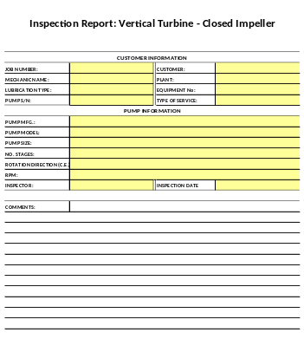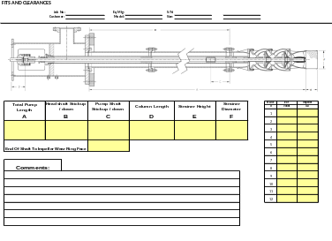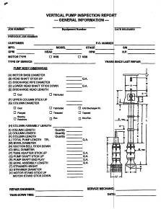

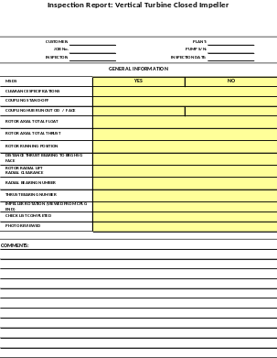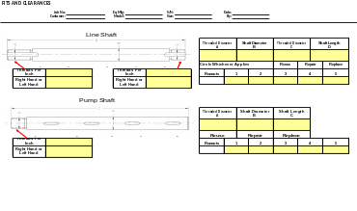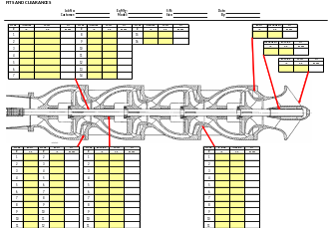
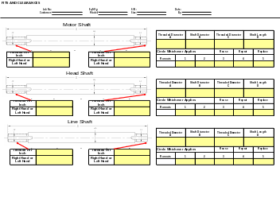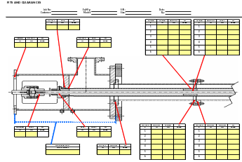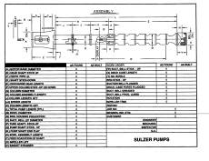
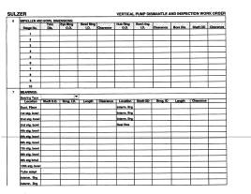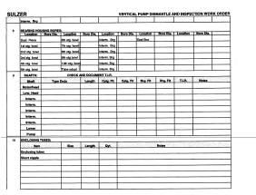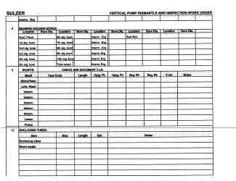
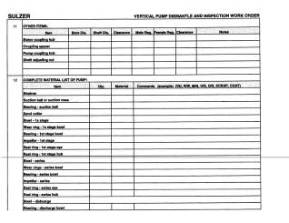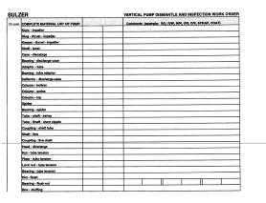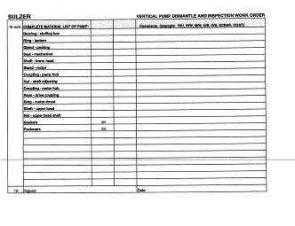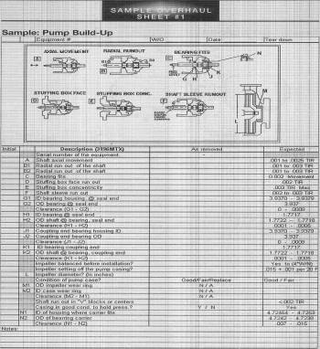

Follow the Manufacturer’s recommendation for lifting and securing when creating your plan for service removal of the pump.

Some of the issues and concerns to keep in mind during the disassembly inspection:

Shaft Misalignment/Bending - some vertical pump designs have a driver/motor that is separate from the pump driving shaft. These commonly require a shaft to be coupled to the motor, or the shaft must slide through the center of a hollow shaft in the motor. When the motor is not aligned properly with the pumping driver shaft, this can result in irregular bending loads on the motor, the pump shafting, and coupling driver is the system requires. Some vertical pumps have long shafts that drive the bowl assembly. It is common to have slight curvatures in the shafts that are caused by mechanical forces or internal stress from manufacturing. Shaft couplings are typically threaded and poor machining of the shaft and/or coupling can also cause failures. Shafts should be straightened (mechanically or with heat) to within .005”/ft. This can result not only in vibration issues, but also in damage to the pump and motor.

Column Pipe/Pump Bowl/Mounting Misalignment - the column pipe that connects the discharge head to the bowl assembly on vertical turbine pumps, can be either threaded pipe or flanged. In either case, the critical and precise alignment of the lineshaft bearing is maintained by way of these connections. Slight variations in parallelism, concentricity or fit due to wear or damage to these connections will result in misalignment pump lineshaft bearings. Misalignment will cause the opening of the clearance between the shaft and lineshaft. Similar to the pump column pipe, alignment of the sleeve bearings in the bowl assembly can be affected by the fit between each bowl, suction bell or top bowl/column pipe connection. Bowls can be either threaded or flanged and parallelism, concentricity and fit of the bowl connections are critical to the life of the pump.

Some of the aspects to be reviewed and documented during disassembly:

  - Shaft Breakage
  - Premature Bearing Failure
  - Motor Base and Support Structure Failure
  - Coupling Failure
  - Motor/Driver Failure
  - Mechanical Seal/Packing Failure
After removal the pump should be placed in a crate designed to keep the pump from secondary impacts and the shaft from bending. Typical crate are made of wood with blocking customized to fit the pump geometry (high end pump crate illustration):
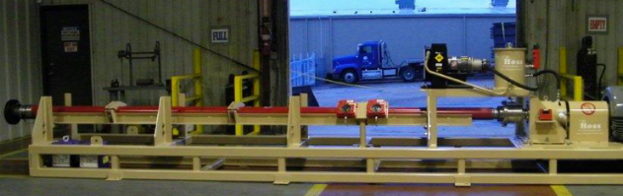
General sequence of work:
- Disassembled pumps are inspected for unusual wear. Take critical measurements (as found) and document with digital pictures the condition of the parts and section of the pump.
- Blast the pump clean and reclaim all machined surfaces back to standard. See Check and clearances checklist above.
  - Inspect the discharge head for signs of erosion/corrosion. If severe wear is found new discharge heads may be required to return the performance to design conditions.
  - Inspect shaft coupling and thread. Rigid couplings are difficult to realign to meet proper standards. If the coupling is no longer running true, replace in kind or with an adjustable spacer coupling, if space is available.
  - Inspect the fit of the motor mount to the fabricated discharge head
  - Inspect the pump column
- Document critical dimensions and clearances at as-found condition, shafts run-outs; provide photos and sketches of critical components with comments pointing to (possible) root cause(s)
- Replacement or straightening of shafts with documented method of strengthening
  - Rotate the shaft on rollers located near each end of the shaft and check total indicator reading (TIR) run out at several points along the shaft.
  - Move the shaft onto V-blocks and straighten by applying hydraulic force or the use of an arbor press. Check the TIR. Maximum acceptable is 0.0005 in per foot of shaft length, but no more than 0.001in within any 1 foot of length
  - If TIR is acceptable, apply thermal treatment in a furnace to relieve any residual stresses per the recommendations in the chart below. The shaft must be suspended vertically during the process so that gravity aids in keeping it straight.
  - Check TIR after treatment. If TIR is unacceptable repeat steps a-c. If the TIR can not be kept to acceptable levels the shaft may have suffered plastic deformation and will need to be replaced.
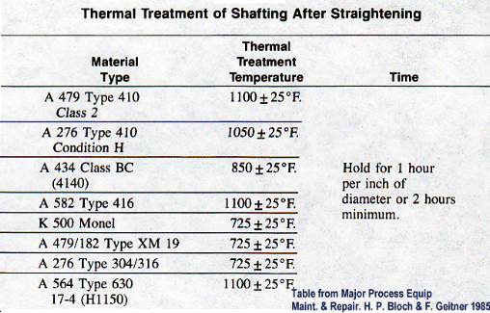
Replacement of bearings (bushings), packings and interstage. If severe wear or corrosion is found in the bearing and bearing holder areas, discuss with the owner the potential need for a bearing material replacement

Present VPRS specification does not cover Levels 1 (Basic) and Level 2 (Extended), considering these inferior with regard to quality and engineering attention required for the power levels and size of pumps covered by this specification. Only Level 3 (Complete Overhaul) is the focus of the VPRS document.

There are many approaches to getting the maximum life out of a Vertical Turbine Pump (VTP) ranging from Run-to-Failure, Scheduled Maintenance and inspection to Vibration and Condition Monitoring for indication of impending failure which are discussed in other sections. For the purpose of this section we will assume that the decision has been made to pull the pump due to either lack of performance, new and excessive vibration or noise, or the conditions have changed and a new bowl or impeller is needed to meet the new condition.

In either of these scenarios the end user/owner typically wants to know what it will cost to do the repair and what will be replaced. This question is similar to asking an auto mechanic what it will cost to fix your car engine that will not start. It is difficult to give an accurate assessment of the needed repairs without inspecting the pump and unfortunately much like a glacier most of a VTP is under water and out of sight and can only be inspected after removing it.

The owner (end user) will often want a not to exceed price for the repair, overhaul and or upgrade and these instances both the owner and the contractor in evaluating must take into consideration the following factors to come up with both a valid cost and determination of what makes financial sense:

- How long has the pump been in service? ( how many hours has it run)
- What has it been pumping? Clean water, Sand Laden water, Chemicals?
- What is the outcome the owner wants? Does the repaired pump only need to last one season or for another 20 years?
- What is the cost of removal and reinstallation as compared to the repair, Overhaul or upgrade?
- How much money does the owner have?
Typical upgrade options for Vertical Turbine style pumps include considerations for material upgrades due to corrosion, cavitation, erosion etc. Bearing/material upgrades for shaft stability or adding bearings for the same consideration. Specialty coatings can be added to improve flow and reduce operating costs. Changing diffuser, impeller and bowl characteristics to increase or decrease flow and head can be considered. There are many re-bowl options available if the current bowl condition is not repairable or the components are no longer available. In closing, upgrade options are specific to the end user and each pump repair/upgrade will involve many site specific considerations:

- wear parts in VTP include:
  - bushings (throttle, line, bowl, foot)
  - wear rings on impellers and in bowls

- what is objective of the upgrade?
  - Longer life - what cause of failure
  - higher efficiency
  - robust design with the engineered upgrade of the old or obsolete design considered
- elimination of lubrication (environmental, complexity, or cost)
- what are the alternative materials: metals/rubber/plastics /carbon/graphites and graphite-metal alloys

In many instances to provide a not-to-exceed price the repair facility may consider that all wearing parts will need to be replaced and based on the bowl size may consider just replacing the bowl rather repairing or rebuilding it and having to machine for bowl and or impeller wear rings and new bearings. As noted earlier, this approach is often an option for smaller pumps, but for larger sizes a partial repair of some components is not an advisable strategy. Instead, a complete replacement of wear parts, couplings, elastomers, and other wear items needs to be considered as a standard approach (Level 3 as discussed above).

BASIC REPAIR
If a small VTP has been in relatively short service (less than 5 years) pumping clean water and develops a problem a repair can be justified since most of the parts will not have much wear. A repair would consist of replacing or repairing the worn components such as bowl shaft, bowl bearings, and minor machining to repair the worst of the worn components or fits. This is typically the least expensive of the options.

EXTENSIVE REPAIR
An extensive repair would consist of a typical repair as described above with considerable machining of the existing bowl and impellers to regain factory tolerances in the wear ring area of the bowl and impellers, Flame spraying of shafts to regain original diameters and buildup of worn components using epoxy compounds and or coatings such as Belzona or Enecon. This can be expensive and may not be justified in bowl assemblies less than 16” diameter due to the relatively low cost of new bowl assemblies.

OVERHAUL
Overhaul may also be termed remanufactured. In this instance the entire pump is gone through and any wearing parts such as bowl bearings, lineshaft bearings are replaced with factory new. Any worn shafts (Impeller or lineshaft) are replaced with new. Impellers and bowls are either replaced or brought back to factory tolerance. If an impeller is worn on the leading edge or vanes it is typically replaced, if the bowl is worn in the wear ring area it is machined and fitted with a wear ring, If an impeller is worn in the wear ring area but is OK in the vanes and shrouds it is machined and fitted with a wear ring to regain original clearances. In an Overhaul of a VTP the pump is returned to factory new condition.
The costs for this vary depending on the size of the bowl but typically an overhaul is anywhere from 50 to 60% of new and will typically provide as long a life as new. A rule of thumb in evaluating an overhaul versus new is if the overhaul exceeds 75% of the cost for new the owner should go with new.

UPGRADE
Upgrade has 2 definitions. It is possible to upgrade a pump by changing the bowl assembly to deliver a new design condition, or you can upgrade an existing pump with new materials of construction, features or design condition.
When considering a change in materials one should consider how much life one received from the original materials. If the original materials lasted 20 years or more it will be hard to financially justify the upgrade. If the pump shows signs of wear in 5- 10 years and upgraded materials will extend the life to 20 it is easy to justify upgrades to the bearings, bearing journals, shaft sleeves and wear rings considering the expense of pump removal.
In upgrading a pump for a different design condition one should evaluate the cost of modifying an existing bowl assembly versus new. If due to a declining aquifer or reduced well production the design flow is reduced and the new condition can be obtained by trimming the impellers the cost is relatively low and makes economic sense. If conditions have changed to require additional flow or head that will require either larger diameter impeller(s) or additional stages the costs increase significantly and it may well justify the purchase of a new bowl assembly. Depending on the bowl size it may be less expensive to purchase a new bowl than purchase parts to upgrade or add additional stages.
If upgrading for performance newer and more efficient bowls and motors may be available that will reduce energy usage and operating cost and may help offset the cost of the upgrade. Some utilities will even provide incentives for improving the energy efficiency of the pumping equipment.
When considering the extent of repairs needed take into consideration the service life of the pump, if it is over 20 to 25 years you can typically expect to be replacing everything rather than repairing or overhauling. After 20 to 25 years any wearing part will be approaching or have exceeded their intended service life and any non-wearing parts such as column pipe and discharge heads will typically be corroded or eroded enough to warrant replacement. The motor will have exceeded its predicted service life and more efficient motors may be available. Below is a brief excerpt from the references provided, noting the general approach within each level of repair:

Level 1 (basic repair) definitions
- Receive and photo document pump “as received” condition.
- Remove pump bowl assembly.
- Remove packing/seal chamber from discharge head.
- Remove head shaft and line shaft/shafts.
- Remove any bearing retainer (spider) assemblies.
- Inspect bearing retainer to column register fits.
- Measure and record “as received” condition. Photo document.
- Disassemble bowl assembly.
- Inspect bowl register fits, bushing/bearing, and case rings.
- Measure and record “as received” condition. Photo document.
- Perform runout and dimensional inspection of shaft assemblies. Record and photo document.
- Perform dynamic balance inspection on impeller/impellers and correct as necessary to ISO G6.3 tolerance and document results.
- Assemble.
- Provide documentation package.

Level 2 (extended repair) definitions
- Receive and photo document pump “as received” condition.
- Sandblast clean for inspection.
- Remove pump bowl assembly.
- Remove packing/seal chamber from discharge head.
- Remove head shaft, line shaft/shafts and coupling nuts.
- Inspect, record and repair/replace as necessary.
- Remove any bearing retainer (spider) assemblies.
- Inspect, record and repair/replace as necessary.
- Inspect bearing retainer to column register fits.
- Measure and record “as received” condition.
- Disassemble bowl assembly.
- Inspect bowl register fits, bushing/bearing, and case rings.
- Measure and record “as received” condition. Photo document.
- Inspect, record and correct all column to head, packing and or seal chamber, bearing and bowl register fits as necessary.
- Inspect and document impeller condition.
- Repair or replace impeller/impellers as necessary.
- Dynamic balance impeller/impellers to ISO G2.5 tolerance.
- Assemble with new fasteners where necessary.
- Replace packing/mechanical seal.
- Prime and paint – standard enamel.
- Provide documentation package.

Level 3 (complete overhaul) definitions
- Receive and photo document pump “as received” condition.
- Sandblast clean for inspection.
- Remove pump bowl assembly.
- Remove packing/seal chamber from discharge head.
- Repair or replace.
- Remove head shaft, line shaft/shafts and coupling nuts.
- Inspect, record and repair/replace as necessary.
- Remove any bearing retainer (spider) assemblies.
- Inspect, record and repair/replace as necessary.
- Inspect bearing retainer to column register fits.
- Measure and record “as received” condition.
- Inspect repair/replace column assemblies.
- Replace steady bearing assemblies.
- Disassemble bowl assembly.
- Inspect bowl register fits, bushing/bearing, and case rings.
- Measure and record “as received” condition. Photo document.
- Inspect, record and correct all column to head, packing and or seal chamber, bearing and bowl register fits as necessary.
- Inspect repair/replace diffusers.
- Inspect and document impeller condition.
- Repair or replace impeller/impellers as necessary.
- Dynamic balance impeller/impellers to ISO G2.5 tolerance.
- Assemble with new fasteners where necessary.
- Replace packing/mechanical seal.
- Prime and paint – two part epoxy.
- Provide documentation package.

3. Predictive AND Proactive maintenance and TRENDING monitoring TECHNIQUES

Predictive maintenance strategy includes several aspects, ranging from simple basics such as visual inspection, to spectral analysis of vibrations, and a gamut of other factors in between.

Predictive maintenance has been adapted to identify machines that are beginning to deteriorate by measuring different variables that determine the condition of the pump and assembly. Guidelines have been developed that are used to define the condition of the machine without disruption of production or disassembly of the machine. When these guidelines are exceeded the pump is considered to be “bad” actions are then taken to place the machine in a “good” condition based on the value of these variables.

Hydraulic Balance – The operation of a centrifugal pump will produce both radial and axial loads on the driving shaft. During the design process, the hydraulic elements are designed to insure that if the pump is operated within the recommended hydraulic performance boundaries, the loads will be in the acceptable design range. However if the pump is operated outside of this range, the increase of radial and/or axial load may induce an excessive load that the pump was not designed to handle. A hydraulic imbalance can also be induced by hydraulic components that non symmetrical. Items like impellers, volute cases, or diffuser bowls that have vane configurations that are not symmetrical can cause a load balance. Hydraulic load balances can be very similar to mechanical rotating element balance, causing high vibration leading to component failures. Vertical turbine pumps must be designed to accommodate the often significant axial loads that result from both the weight of the rotating element and the hydraulic forces which can be in either direction (up thrust or down thrust). Typically thrust bearings are located in the motor and are sized for the calculated down thrust which is directly related to the discharge pressure and affected areas of the rotating element. Up-thrust conditions accentuate inaccuracies in shaft straightness and bearing clearances.

Unless a catastrophic failure has already occurred and it is impossible to assess a pump operation, it is best to conduct a performance review and level of vibrations prior to a pump removal. Such base line data will help to assess the effectiveness of the upcoming repairs, by comparing a pump performance and vibrations: before and after the works.

Condition Monitoring for Vertical pumps is unique in that the majority of the machine is not easily accessible, since the pump section is below the surface. Typical condition monitoring techniques such as vibration, oil analysis, & thermography cannot be used on the sections below the surface if the shaft bearings or bushing are lubricated by the product. An area that is often overlooked in condition monitoring is to periodically monitor the condition of the electrical portion of the motor as well as the condition of the power being supplied to the motor.

However, when adopting any predictive technology the basic premise any technology chosen should be easy to apply, non-destructive, and use standard easily understandable measurements. It is also important to understand that all predictive maintenance technologies have three phases, Detection, Analysis and Correction.

Non Compatible Pumped Fluids – the physical characteristics of the fluid must meet the capability of the pump. Insuring that the viscosity, specific gravity, temperature, corrosiveness of the fluid, solids content, vapor pressure, and other key factors match the capability of the pump is critical. Excessive wear, vibration, or poor performance can result:

- Motor/Driver Failure
- Premature Bearing Failure
- Shaft Breakage
- Motor Base and Support Structure Failure
- Coupling Failure
- Mechanical Seal/Packing Failure
- Erosion/Corrosion of Impeller Vanes or other pump hydraulic components
- Physical Damage to Pump Elements Due Large Solids

Poor Lubrication – The rotating element of a pump requires some lubrication to reduce friction and remove heat. Some pump designs utilize ball or roller bearings that are grease or oil lubricated. Other designs use the pumped fluid or an outside source of fluid to lubricate the bearings. The improper amount of lubrication or use of the wrong fluid can result in pump breakdown.

- Shaft Breakage
- Premature Bearing Failure
- Motor Base and Support Structure Failure
- Coupling Failure
- Motor/Driver Failure Mechanical
- Mechanical Seal/Packing Failure

The purpose of the detection phase is to surveys as many machines as rapidly as possible and to identify as many faults as possible. This means that in many cases more than one technology may be chosen depending on the type of fault or faults expected. Normally the technology chosen for the detection phase provides an indication that the pumps condition has changed, but is insufficient to fully identify the cause of the change. The trade off is the time required to perform the survey. Most mature predictive technologies will find new problems about 1 to 2% new problems each survey.

In the analysis phase additional information, testing or even technologies may be employed to more accurately determine the cause of the change in the pump or motors condition.

In the correction phase a plan of action is determined that will minimize any future damage yet reliably operate the pump until repairs can be affected. In some cases of mechanical faults the correction may be something as simple as realignment, in-situ balancing, or something more complex such as replacing a bearing, coupling or other minor repairs.

Electrical issues may be equally as simple as tightening connectors, drying out the windings or as complex as a complete rewind.

Experience and studies by EPRI and other organizations have well documented, that in order to determine faults occurring in the submerged portion of the pumps using vibration analysis, it is necessary to mount the vibration transducer on the pump element itself below the mounting surface. This may be economically feasible for critical pump applications but uneconomical for non-critical applications. Generally any vibration or vibration changes measured on the motor above the surface is normally a fault above the discharge stand or the attachment plate. When changes in the vibration measured on the motor do actually occur, as the result of a pump failure, the pump assembly is normally completely destroyed.

These methods are still effective for determining the condition of the mechanical portion of the motor and other portions of the pump system above the surface, such as the balance, alignment, and or the bearing condition.

To test the condition of the electrical portion of the motor, periodic monitoring of the motor windings from the Motor Control Center (MCC) using Motor Circuit Analysis (MCA) is required to determine the condition of the windings and to identify developing winding shorts and insulation degradation to ground while the motor is de-energized. Thermography may be used to identify lose connection and other issues in the distribution and control system.
Using Motor Circuit Analysis all three phases of the motor windings should be balanced using both DC winding resistance and AC reactance measurement to fully evaluate the condition of the motor windings.

MCA injects a low voltage AC sinusoidal (< 10 V) signal into each of the three phase windings and exercises the insulation system. This provides a non-destructive test of the winding to identify developing winding issues.
Prior to assembly the motor windings should be checked for balance with the rotor removed from the motor

Winding resistance:+/- 5% of average of all three phases
Winding Inductance: +/- 5% from average of all three phases
Winding Impedance: +/- 3% from Average
Phase angle: Balanced
Variable frequency Balanced

Electrical Signature Analysis (ESA) should be used to identify the mechanical and flow condition of the components and fluid located below the surface as well as the condition of the power being supplied to the motor periodically.
An important aspect in any predictive technology is the test interval. There are no established, generic monitoring intervals that cover all technologies, industries, or operations. Plant conditions, operating environment and commitments, selected technology, and other plant considerations need to be considered.

Each technology generally provides recommended initial monitoring guidelines and test intervals. However, regardless of the technology, all machines should be monitored to some extent and a baseline should be established. Other considerations are the critically of the machine, the cost of repair, causes, types and consequences of failures.

The operating environment, pumps mounted indoors can be monitored at greater time intervals than pumps mounted outdoors. Pumps with more frequent starts should be monitored at shorter time intervals than pumps that operate with longer time intervals.

These same variables that are used to define bad pumps can be used to place the pump in a “Precision” condition. This Proactive approach often puts the pump in a condition that is better than new. This proactive approach recognizes that taking the additional time to put the machine in its best condition by understanding that these guidelines are designed as the maximum allowable and often times

Companies have learned to maximize the use of predictive technologies. If these technologies can be identify bad machines from good machines it can also be used to identify precision machines.

Placing machines in precision condition often requires nothing more than doing the job right the first time, in many instances making the machine run better than when it was new.

Precision maintenance requires a understanding of how to make these machines operate at their optimum condition and how to keep them there.

Making your production built rotating equipment operate as a precision hand-built machine requires nothing more than a basic understanding of what causes your machines to wear, how to place them in their optimum condition, and how to maintain them in this condition during the complete assembly and rebuild process.

The extra few minutes spend up front in precision balancing the rotor, combined with proper installation of the bearings, and the extra few steps required to obtain precision alignment all pay huge dividends in extended life of the machine and improved quality of the product. Mechanically this means placing the pumps in “Precision” condition by balancing the rotors to Precision Tolerances instead of Good tolerances, as well as aligning the shafts to Precision tolerances vs good tolerances and precision fit of the bearing.

Electrically obtaining precision means placing the power driving the motors at its best quality, and eliminating electrical issues in the motor such as casting voids, and eccentricities within the rotors, as well as any impedance unbalance and other winding issues in the stator windings.

Vibration level is one of the important ingredients of this, and can also range from simple periodic measurements of the overall (RMS) levels, to a full spectral (FFT) analysis:
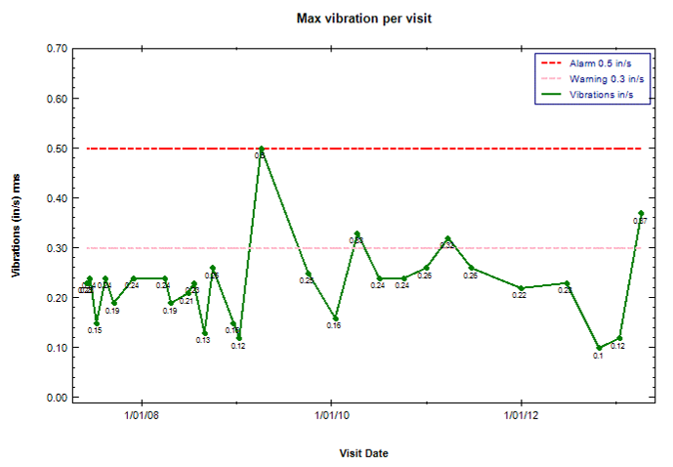
Fig. Overall vibrations are tracked at periodic intervals (monthly, quarterly, etc.), and are measured in inches per second. Allowable Warning and Alarm levels vary depending if a brand new pump is being commissioned or an existing old installation is being evaluated. Typically, new pumps have a much tighter (lower) allowable limits, reflecting good condition of the entire system at that time (foundation, baseplate, anchor bolting, etc.)

Allowable vibration levels for vertical pumps also depend on the location of the sensors, pump energy, geometry, height of the motor, etc. A typical Warning value of 0.30 in/sec is a good target, providing a simple decision oriented approach to evaluation of the vertical pump condition, without having to consult design charts, making measurements, and other assessement, which would normally be applicable for newly commissioned as-factory-built units, with spec approved (new) foundations.

The Alarm level is typically set at 0.50 in/sec, and also within the objectives of a simple practical assessement of the existing (old) installations, similar to a Warning value setting as discussed above.

Within the Predictive method, a more detailed analysis of a pump condition is done when the overall level of vibration begins to exceed the Warning level, i.e. only applied when specifically required, and not routinely on every pump. An example of the FFT (spectral analysis) trace is shown below:

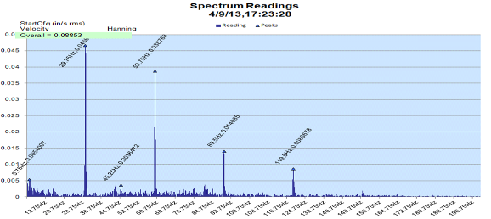

Fig. A full spectral analysis showing amplitudes of vibrations as a function of frequencies. In this case, the overall level is below the Warning (0.088 in/sec as shown, i.e. significantly below the allowable 0.3 in/sec), and thus the FFT analysis was not necessary. Note however, multiple harmonics of a running speed (29.75 HZ = 1785 RPM) indicating possible internal looseness developing inside of this pump, although still at the very initial stage.

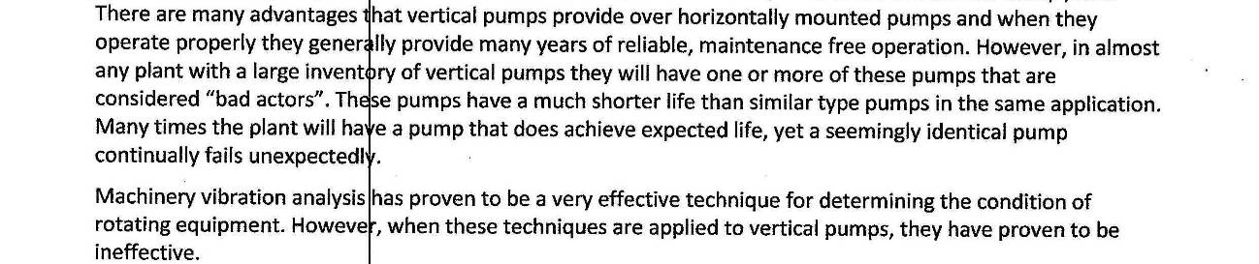

For new units, the ISO 10816 is used to assess the condition of the newly commissioned pump in the field.

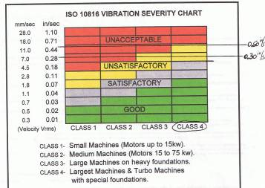

Fig. ISO 10816 is used to assess vibration of the newly commissioned pump/motor units

For critical units, a next step of attention is brought out by applying a Proactive maintenance approach. An example of such strategy would be instrumenting the unit with real-time vibration monitoring sensors, to detect and track instantaneous value of vibrations, with ability to react quickly should a problem be detected.
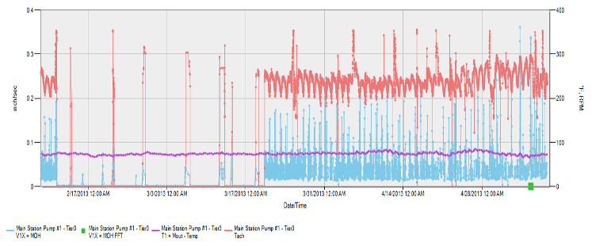

Fig. Proactive approach: vibrations, temperatures, RPM are monitored continuously. Data typically displayed at 5 seconds intervals, unless a signal value changes faster than that, within the pre-set allowable band for the change of a value. Note a green block at the right corner of the graph, indicating availability of the FFT spectral data for a review if needed

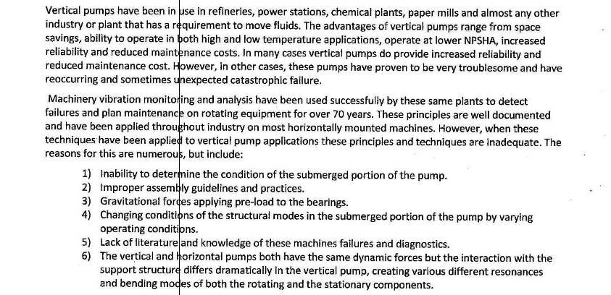

Catastrophic failures usually follow the “bathtub” curve – the initial soon-after-the-repair failure (infant mortality), or at the end of the life cycle (aging). Infant mortality is reflective of pump problems not properly corrected or neglected, during the repair (or initial production), or as system related. Usually, for the great majority of cases, the time-to-fail is from immediately upon the start-up, and up to 24 hours.

The aging (final) stage of failures depend on many factors, ranging from a pump-related issues (improper materials of construction, incorrect selection of clearances or incorrect relationship between clearances of the impeller versus bushings, versus register fits, etc.), to system-related issues (operating too far to the left or right off the BEP point), overly abrasive pumpage (such as the ingressed sand for the vertical river raw water intake pumps), etc.

A failure analysis of catastrophic failures naturally lacks much of the desired evidence, but an effort should still be made to identify, at least potentially, a likely root cause. For example, a twisted shaft might still leave the evidence of sharp edges of the grooves, acting as stress risers, providing hints on improving the manufacturing of the replacement shafts.

Possible Root Causes of failures and RCA (root cause analysis) are illustrated by an example in Reference-2.

4. Vibration Analysis for pumps and motors
What is “resonance” and why should I be concerned about it. Before we indulge on this very important topic, let’s first provide the basics of “vibration” from both a “Motor-only” and complete “Pump-Motor System” perspective.
Vibration
Vibration is a term that describes oscillating motion in a mechanical system, or alternately, an oscillating force applied to a mechanical system. Vibration can be measured in terms of displacement, velocity, and acceleration. There are two basic components of vibration: Frequency & Amplitude
Frequency
Fig.1
It is a movement of a point on a vibrating object over time that produces a graphical representation of a simple harmonic motion and is shown as a sine-wave. The Y-axis indicates Peak-to-Peak displacement (amplitude) while the X-axis indicates time (Fig.1).
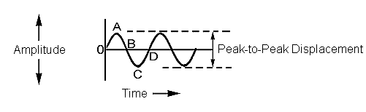
- “O” indicates the point at rest on the object / system
- “O” to “A” shows the upward movement from rest
- “A” to “C” is the movement from its upper limit to the lower limit as it passes through its normal at rest position, “B”
- “C” to “D” is the movement from its lower limit back to its normal (at rest) position

The frequency of vibration is the number of times this cycle occurs and is expressed as “Hertz” (cycles per second) or as “CPM” (cycles per minute)
Time required to complete one-cycle is known as the period of vibration which is equal to 1/frequency (Fig.2)
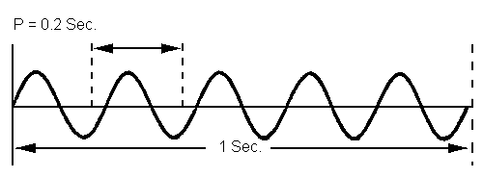
Fig.2
The above indicates 5-cycles of vibration over one second.
- The frequency is 5 Hz or
- 300 CPM (5 Hz x 60 seconds) and
- The period is 1/F = 1/5 = 0.2 seconds
One period of vibration occurs every 0.2 seconds
Amplitude is the displacement, or maximum extent of a vibration or oscillation measured from the position of rest or equilibrium. Amplitude is typically measured in IPS (inches per second) on vertical turbine pump systems.
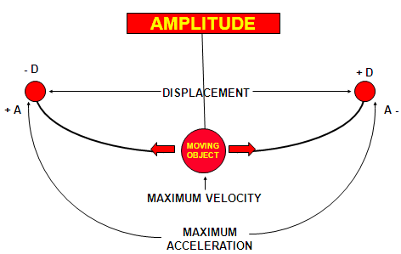
Fig.3
Amplitude is broken down into 3-components: Displacement, Velocity, and Acceleration
- Displacement is the actual physical movement of the vibrating object. The change of position which occurs over one cycle relative to its initial position. Peak-to-Peak displacement is the total distance from the upper limit of travel to the lower limit of travel. The normal measurement is in thousandths of an inch called Mils. (One Mil = 0.001”)

- Velocity is the speed at which displacement occurs. Velocity is not a constant value, as it varies throughout the cycle. At peak displacement, the value of velocity is zero since it is about to change direction and must stop to do so. (as point “A” and “C” in Fig.1). However, midway between the peak displacement values (points “B” and “D”), velocity is at its maximum value. The peak value of velocity is what we are interested in. Velocity is measured in “inches per second Peak”.

- Acceleration is the time rate of change in velocity and like velocity; it varies throughout the cycle with the greatest acceleration occurring at the peaks of the cycle where direction reverses. Acceleration is measured in G’s RMS.
Basic Vibration waveforms and measurement units (Fig4):
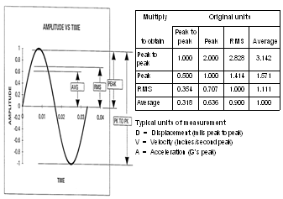
Fig.4

Motor-Only Vibration
Vertical Pump Motors are to comply with National Electrical Manufacturers Association (NEMA) MG-1 standards for maintaining limits on mechanical vibration. NEMA states that the mechanical vibration for medium horsepower, alternating & direct current machines built in a 140 and larger frames, when measured in accordance with NEMA MG-1 Part 7 shall not exceed a peak vibration velocity of 0.15 inches per second peak (Fig.5).
Fig.5

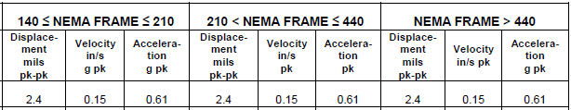
Excitation – Forcing Phenomena
Vertical Pump Motors have both “mechanical” and “electrical” forces which influence overall vibration within these machines and are noted in below Fig.6:
Fig.6

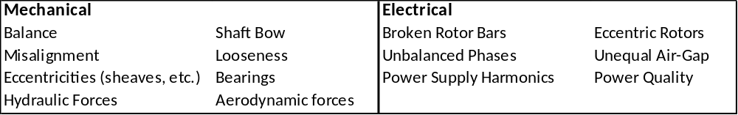

Frequency Domain
The frequency domain can be divided into three main areas of interest to the analyst:
- Synchronous
- Sub-synchronous
- Non-synchronous
Synchronous Components are phase locked to running speed.
N x RPM
(N is an exact integer)

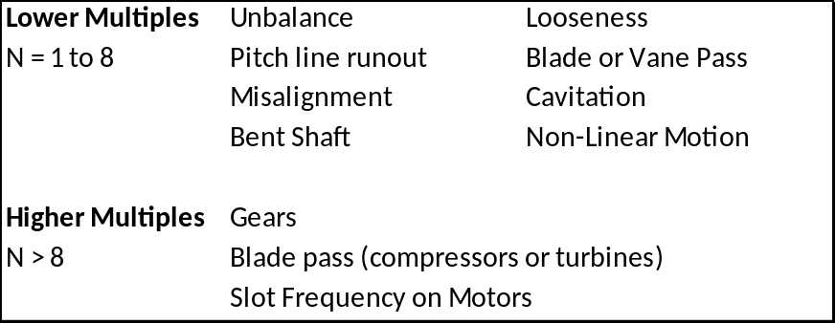
Sub-Synchronous Components are components where frequencies are below running speed.
< 1 x RPM
These components consist of:
- Another component in machine or another machine
- Primary belt frequency
- Hydraulic instability (oil whirl and whip)
- Rubs
- Anti-Friction bearing loose in housing
- Cage Frequency of anti-friction bearings
Non-Synchronous Components are components where frequencies are above running speed, and are not integer multiples of running speed.
= F x RPM
(where F > 1.0 and not an integer)
These components consist of:
- Another component in machine or another machine
- Multiples of belt frequencies
- Anti-Friction bearings
- System resonances
- Process
- Electrical
- Other (chain drives, U-joints, centrifugal clutches, lube pumps, compressor surge, detonation, sliding surfaces)
Spectrum Analysis
When analyzing vibration in detail, it’s critical to understand the entire vibration spectrum. This is achieved by capturing the vibration levels across the entire frequency range through Spectrum Analysis. This analysis captures the dominant frequency, power, harmonics, bandwidth, and other spectral components of a signal in time domain waveforms. The display plots the frequency on the horizontal axis and amplitude on the vertical axis (ref Fig.7).
Fig.7
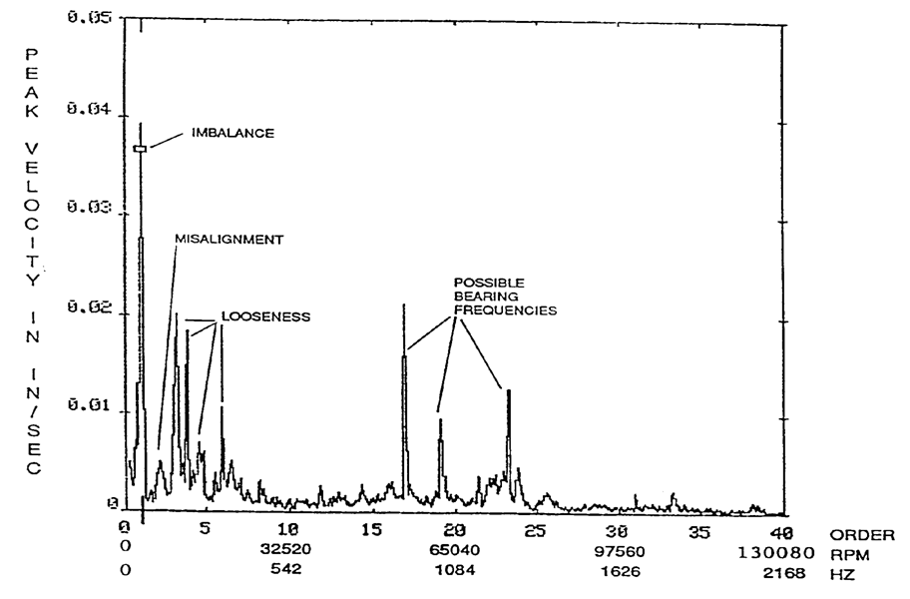

- Vibration amplitude indicates the severity of the problem
- Vibration frequency indicates the source of the problem
Resonant Frequency and Critical Speed
Critical Speeds are usually nothing more than natural frequencies being excited by unbalances or misalignments from the rotating system. The rotor natural frequencies are usually the most pronounced. Common practice is to attempt to reduce the effects of critical speeds by beefing up the supports or shaft system, however the most effective method is to control the exciting force by improving the balance of the rotor. However, the natural frequency of any support structure can be excited by any residual unbalance in the rotor. It is common to have the natural frequency of vertical turbine pumps to be below the running speed of the pump and depending on the supporting structure this can be near the operating speed. If a natural frequency is near the vane passing frequency these forces can be excited by the hydraulic forces developed as the vanes pass the cutwater. Impeller vane passing frequencies can also be a factor.

Now that you understand the basics of vibration, we’ll now discuss about “resonance”. A Resonant Frequency is a point on the system response curve where the response amplitude is at its greatest resulting in its maximum “vibration”. There are three basic elements to resonance:
- The presence of a natural frequency
- A mode shape
- A forcing function
A natural frequency is a frequency at which a part vibrates when excitation is removed. It is a function of mass (m) and stiffness (k) of connected system parts. The natural frequency can be derived from the following formula (Fig.8):
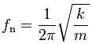
Fig.8
Excitation frequency is the harmonic component of a periodic forcing function. When excitation frequency coincides with a natural frequency, a condition called resonance can occur in which high vibration may be encountered. This resonant condition will show up as a peak in the response curve (vibration amplitude versus operating speed plot). The operating speed at which a peak is encountered is called a critical speed. Depending on the structure, there may be multiple peaks or multiple resonant modes. The magnitude of the vibration depends on a number of factors. These factors include the magnitude of the excitation, where the excitation is applied on the mode shape for the part, and the presence of damping and its location. All systems have some degree of imperfections which results in excitation. From the above, it should be obvious that the primary concern with resonance is high vibration and the possibility of premature failure.

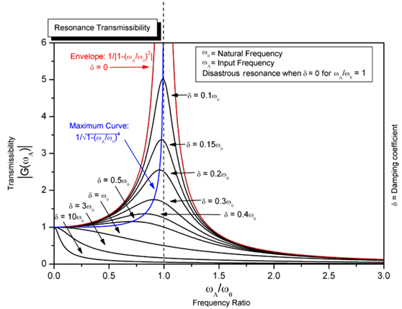

In the case of vertical turbine pumps, there are 3 types of resonant frequencies that are typically encountered. They are:
- Rotor Bending (lateral critical speeds)
- System Reed Frequency and Structural Bending
- Torsional
Rotor Bending
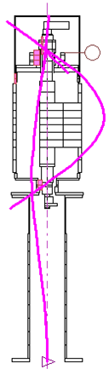
Rotor bending resonances are usually a problem in large motors operating at 2 pole speeds and above. The primary excitation for these modes is rotor unbalance. Rotor bending resonances can usually be found in testing the motor as a component, and therefore, it is usually resolved before the motor is shipped. The one exception to this is when there is a large overhung coupling or a rigid coupling. These may not be found until they are tested as a connected pump-motor system in the field. Vertical pumps may also have long shafting segments that are guided by bumper bushings. These segments, if not properly sized and supported, can produce a resonant condition. The resonance will cause the line shaft to “sing”.
First Rotor Bending Mode Shape

System Reed Frequency and Structural Bending
System reed frequency and structural resonances are the most common problems encountered. They are usually encountered in larger motors mounted on flexible pump heads and operating at 2 pole speeds and above. They can be very difficult to solve especially if they are operated on a variable speed drive with a wide operating range. The larger (heavier) the motor, the lower the resonant frequencies. Since this is a “System Resonance”, the motor manufacturer has no control of the final system resonant frequencies. The motor manufacturer’s responsibility is to provide motor-only data to those with system responsibility (usually the pump manufacturer) so that they can calculate the system response and make the necessary system modifications to prevent the resonant frequencies from encroaching on the required margin of separation. The data provided by the motor manufacturer for this analysis cannot be easily calculated. “Estimates” of typical data² (Fig.9) are usually provided by the motor manufacturer to assist pump assemblers in calculating “system” Reed Critical Data during the design stage (Reed Critical Frequency; CG = center of gravity; Deflection @ CG; Motor Weight).

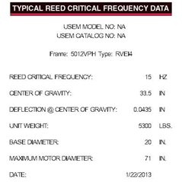
Fig.9

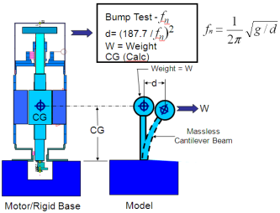
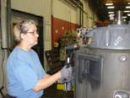
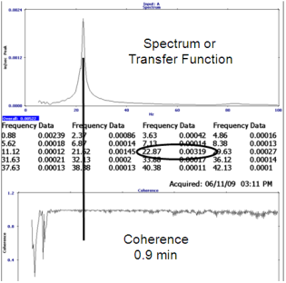
To provide the most accurate Reed Critical Frequency (RCF) data, the motor manufacturer can perform a RCF test, commonly referred to as a “bump test”, with a calibrated hammer with the motor mounted on a rigid foundation prior to shipment (Fig.10). Top tier motor manufacturers have dedicated RCF test foundations to simulate an “infinite massive foundation” to accurately measure the motor-only. The test provides the resonant (RCF) for the motor by itself. The motor manufacturer also provides the motor weight, motor static deflection, and center of gravity. Of the three items, static deflection is the hardest to determine.
Fig.10
The motor reed frequency determined from the bump test is used to back calculate this deflection. With this data, the pump system designer can make a complete model of the system including the motor, pump head, and any other components down to the foundation. Using hand calculations or a more sophisticated FEA analysis, the reed frequency of the system can be calculated. Note that is a single degree of freedom model for the motor portion of the system. To calculate the second and higher structural resonant frequencies requires more details on the construction of the motor.
Torsional
System torsional frequencies are probably the most difficult to identify. They consist of mass inertias twisting in synchronous or out of synchronous to each other. This twisting of the shafts connecting the inertias results torsional alternating stresses and possible a fatigue failure of the weakest components (coupling or shaft extension). Although there are number of excitation sources, the one that comes to mind is the blade passing frequency for the pump impeller. There are a number of programs, both FEA and transfer matrix, that are capable of calculating the torsional natural frequencies (TNF) of a system and response to excitation. Without the addition of a coupling with damping, these systems have very little damping and resonate conditions should be avoided. Usually the motor by itself is a single degree of freedom and has no torsional resonance. As with reed frequencies, this is a system problem. The motor vendor’s responsibility is to provide motor mass elastic data to those with system responsibility (usually the pump manufacturer) so that he can calculate the location of system resonant frequencies and make the necessary system modifications to prevent the resonant frequencies from encroaching on the required margin of separation.
Mode Shapes
How does the mode shape affect resonant vibration amplitudes? The mode shape depicts the vibration shape for a natural frequency. Mode shapes have high and low spots (ref Fig.11)². Where the mode shape passes through a zero deflection point (zero displacement), it is called a “node”. Where the mode shape has a peak (maximum displacement), it is called an “anti-node”. When the excitation is applied at an anti-node, the resonance will be difficult to excite. When the excitation is applied at a node, the resonance will be easy to excite and high amplitudes may be encountered. This also applies to location of vibration pickups. The amplitude at a node will be relatively small while the amplitude at anti-node will be relatively large.
Fig.11
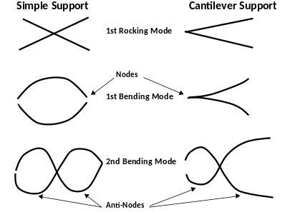
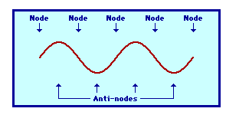

The mode shapes vary slightly depending on the mounting design. The two mounting designs are the “Simple Support” which has the spring system mounted between two supports. The second mounting support is the “Cantilever Support”, which is supported only on one end with the spring component free at the opposite end (similar to a vertical pump system design).
The first natural frequency bending mode on a component that is a simple support system has one anti-node and two nodes. The first bending mode of a cantilever mounted spring system has one anti-node and one node. As a component’s higher order of natural frequencies is progressively excited, their mode shapes take on an additional node and anti-node. The 2nd natural frequency in a simple support system will have three nodes and two anti-nodes. The cantilever systems 2nd bending mode will have two nodes and two anti-nodes.
As noted above, in a Pump System the mode shapes are typical of a cantilever beam with the 1st and 2nd mode shapes the primary contributors to system resonance issues encountered in the field. Below Fig.12 shows these mode shapes encountered within these systems.
Fig.12
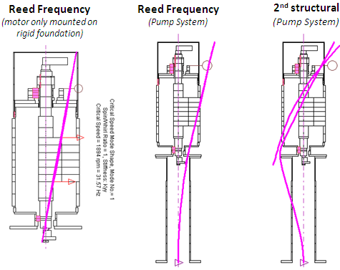
How does damping affect resonant vibration amplitudes? A damper placed in the right location will dissipate energy and result in lower amplitudes. With the proper damper and in the proper location, it is possible to run on a resonant frequency with negligible increase in vibration. An example of this is the case lateral critical speeds of rotors with hydrodynamic bearings. The hydrodynamic bearings can provide enough damping to produce acceptable response. Unfortunately, most motors have very little damping and operating on a resonant is detrimental to their life.
Margin of Separation
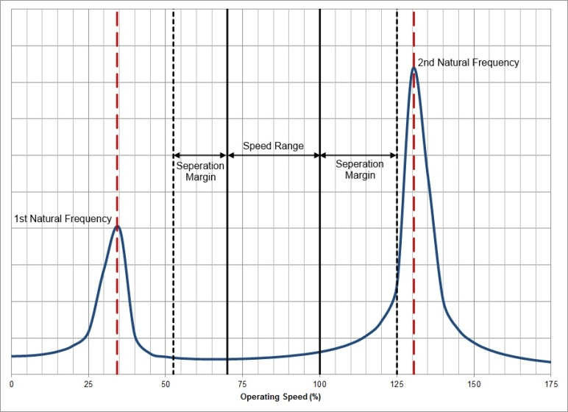
What is “margin of separation”? Margin of separation is the relative location a resonant frequency to the excitation frequency (ref Fig.13)³. In the design stage, the margin of separation acts as a safety margin. It not only includes the accuracy of the method of determination of the resonant frequency but it also must include a margin to cover the width of the response, i.e., the rise and fall in vibration amplitude. Some of the methods of determination include modeling the structure and calculating the resonant frequency. If a crude model is used, the calculated results may not be accurate and a larger margin of safety should be used (such as 25%). The model must contain sufficient degrees of freedom to represent the mode shape of the highest resonant frequency mode in the operating range. If not, some resonant frequencies will be missed. If a very refined finite element model containing correct representation of the components and the connection of those components is used, the margin of safety can be lowered (such as 20%). In should be noted that even with a detailed accurate FEA model, it is often necessary to calibrate the model using accurate test results. Another method of determining the location of the resonant frequencies is by testing. Unfortunately, it is usually not possible to wait for the test results in order to complete the system design. If it is a new structure that has never been tested before, the margin of separation must be high (such as 20%). If the structure is identical to one built in the past, a lower margin of separation can be used (such as 15%). It should be noted that even in testing of identical motors, the measured resonant frequency can vary by 10% from testing and manufacturing variances.
Fig.13

The following are the methods used to produce acceptable response to resonant frequencies.

Lateral Critical Speeds
Detune by raising or lowering the resonant frequency of the motor only. Raising the resonant frequency to produce a stiff shaft design can be achieved by one or more of the following:

- Reducing the weight (mass) of the rotor
- Increasing the shaft diameter
- Reducing the bearing span
- Increasing the bearing stiffness
Lowering the resonant frequency to produce a flexible shaft design is not as easy. There must be sufficient damping (hydrodynamic bearings or squeeze film damper) in the rotor-bearing system to produce an acceptable response when operating on or through the resonant condition. The opposite actions to those stated for raising the resonance, will lower the resonant frequency. All of the above actions require a major redesign.

Reed Frequency:
Small motors have high resonant frequencies when rigidly mounted, and even when placed into a system, the reed frequency will have sufficient margin of separation above the operating speed range. On the other hand, large motors have lower resonant frequencies that could be as low as 15 Hz. When placed in a system, the reed frequency will be further reduced. If the motor reed frequency has an unacceptable low reed frequency as a motor alone, there is no way for the system to have a reed frequency above the range. The system properties can lower the reed frequency by 50%. There must be sufficient margin above the operating speed such that the reduction provides adequate separation margin. Therefore, the system must be designed to operate below the operating speed range.
Torsional Resonance:
Torsional resonance is a system problem and is most easily resolved at the design stage. Measurement in the field is difficult and usually requires strain gaging the coupling or shaft. There are a number of programs, both FEA and transfer matrix, that are capable of calculating the torsional natural frequencies of a system and response to excitation. Without the addition of a coupling with damping, these systems have very little to moderate damping and resonate conditions should be avoided if possible. This resonance can be detuned by raising or lowering the resonant frequency. Raising the resonant frequency can be achieved by one or more of the following actions:
- Reducing the Inertia of the rotors
- Increasing the torsional stiffness of connecting shafts and coupling.
The opposite actions to those stated for raising the resonance, will lower the resonant frequency. The system should be modified such that there is a safe margin of separation. Running on a torsional resonance should be avoided. If the resonant frequency has be traversed during startup and shut down, it should be infrequent or possibly a skip over circuit could be incorporated. If this traversing is frequent, a torsional response analysis can be performed along with a fatigue analysis. If life is not sufficient, a coupling with damping (rubber blocks) may be the solution.
Evaluating Vertical Pump System Vibration in establishing Root-Cause
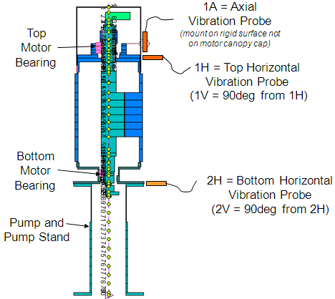
Now that you’ve learned the basics about Vibration and Resonance, what do you do if you experience high vibration (> 0.30 IPS) in the field? The first step would be to take once per revolution vibration (amplitude and phase) as well as spectrums at the top and bottom of the motor-pump system in planes 90 degrees apart (1H, 1V, 1A, 2H, 2V). These measurement locations are shown in Fig.14.
Fig.14
For small pumps, the exact position of the probe is not criitcal⁴. Because of the bearing housing’s small size, there is not much room to choose the exact location of the probe. The typical error does not change much more than 0.01 to 0.02 inch/second or so. Typical field allowances are usually 0.3-inch/sec (warning) and 0.5-inch/sec (alarm). In most cases, an absolute value is not as important as trend data (Fig.15).
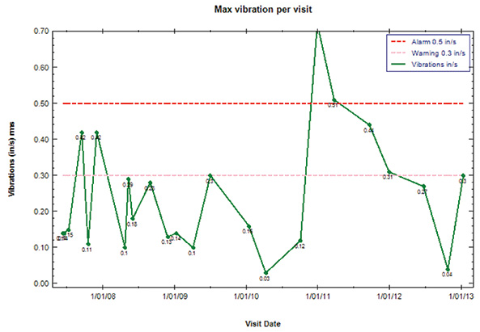

On larger units, probe placement can make a big difference⁴. Locating the probe on the same housing (pump bottom in relation to the coupling) but on the inside (assuming enough room to insert the probe) may show a significant different reading.
Fig.15
With larger housings, different parts will vibrate at significantly different levels. This difference, however, is not a direct indication of a bearing problem. The differing vibrations may indicate the structural integrity of the housing, such as cracks in certain areas, loose bolting or the attachment to the main body.
During vibration measurements, if the largest amplitude is at rotational frequency, it could be the result of operation on a 1st (reed) or 2ND structural resonance. The easiest way to identify which mode, is to look at phase angle of the once per revolution vibration at the top and bottom of the motor. If they are in phase, it is likely the reed frequency. If they are 180 degrees out of phase, it is likely the 2nd structural frequency. We cannot rule out excessive unbalance that may be caused by shipping damage or coupling unbalance. Correcting this issue in the field may be as easy as to “lock-out” the speed from the range which has a natural frequency if system is equipped with a Variable Frequency Drive. If this is not possible, the next step might be to trim balance the motor in the field (on the pump) or remove the motor from the pump head for vibration measurements at a repair shop. Measurements should be taken with the motor mounted on resilient supports. If the once per revolution vibration measured is low (< 0.15 IPS per NEMA), It is most likely the high vibration when mounted on the pump stand was due to a structural resonance. It probably is a good idea to bolt the motor down to a heavy foundation and perform a bump test to verify the reed frequency of the motor. This data can be used by the responsible party for the system analysis to verify the system design. If the spectrum taken did not show high vibration at once per revolution, but is some other frequency, we have to look for different sources. For example: if the highest amplitude is at 2-times rotational frequency, we might be look at misalignment as the cause. If the highest amplitude was at 120 Hz, it may be due to a electromagnetic source in the motor. In this case the vibration amplitude will instantly drop when the motor power is cut. If the highest amplitudes are at non integer multiples of the rotational speed, we might be looking at a bearing problem. Other solutions would be the addition of a motor stand or tuning (spring) plate between discharge head and motor which will decrease the natural frequency. The addition of ribs to discharge head will stiffen system and increase its natural frequency.
Remember, before commissioning the system, the installer needs to conduct the following:
- Capture all Vibration measurements outlined above
- Use acceptable vibration limits in IPS-Peak.
- All data must be labeled as to “rms” or “peak”
- Should include spectrums and modal bump test. Measurements are to include phase angle to determine if second structural is evident.
- Don’t commission a unit without both top and bottom readings.
- Vibration limits to follow Hydraulic Institute Guidelines for top in addition to bottom.
As noted, knowing the basics of vibration and resonance will go a long way in solving complex vibration problems encountered in the field.
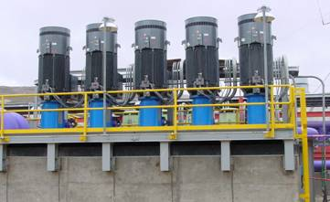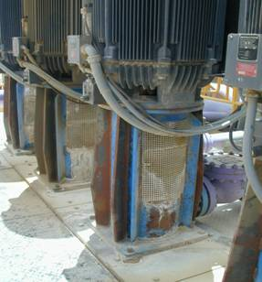

5. Foundation, Baseplates and Mounting System

Each style of pump requires a particular type of mounting system per the manufacturers specified guidelines. However, the fundamental requirements are most often the same. The mounting must be made rigid and not allow flexing of the pump assembly during operation. All piping connections made to the pump should be flexible and allow isolation of the pump from the piping system. Check valves and other ancillary piping equipment should be designed to not induce hydraulic or mechanical loading on the pump assembly. The natural frequency of the mounting system needs to be well outside the frequency of the pumps operation range (from full off to full on and back to full off) to remove any induced vibration into the system. Poor mounting can result in a number of failures.

- Damage to the mounting fasteners, hardware or mounting structure
- Damage to the pump housings or components
- Damage to the piping system.

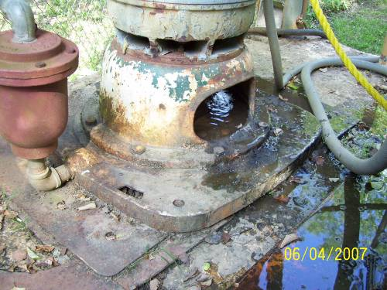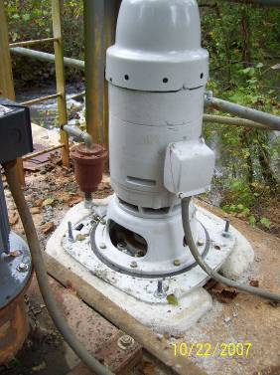

Fig. Before (left) and after (right) pump sole plate, with repaired and properly set grout

6. FIELD WORK, TOOLS, AND SITE ACCESS

Pump and Driver pre-removal planning

The vertical turbine pump is both one the simplest and most difficult pumps to remove. Simplest because there is typically only a discharge pipe to disconnect and a few bolts that secure it to either a sole plate, sump or suction barrel flange. It is the most difficult due to varied site conditions and the desire and need for safety. Unfortunately many pump station designs do not consider how the pump will be removed after the facility is constructed which leads to challenges for the owner and or contractor tasked with removing it.

Proper pre removal planning will assure both safety of the crew and cost control for the owner and prevent any damage to equipment in the removal process.
Setting clearances

The rotating element (shaft and impeller) must be raised axially prior to starting the pump. The vertical distance from the impeller skirt to the point-of-contact with the bowl is critical to both performance and equipment life. This distance is set at either the top adjustment nut of a vertical hollow-shaft motor, or at the drive coupling of a vertical solid-shaft motor.

In the case of deep well pumps, the amount of shaft stretch must be considered. Also, all vertical turbine pumps have a downthrust vector that is specific to that particular bowl/impeller combination. There is no “standard” clearance setting. The correct setting should be stated in the IOM Manual furnished with the pump. If that is not available, contact the OEM advising the Model and Serial Number of the pump.

Setting clearances of the bowl assembly and wear rings with respect to the impeller and shaft must be maintained to within the tolerances set by the pump manufacturer. These tolerances take into consideration the downthrust force on the impeller, vibration due to shaft runout and impeller imbalance and thermal growth of casing and rotor where larger temperature differentials in the pumped fluid is present.

Key dimensions to confirm are:

- The distance from the bottom of the impeller to the end of the shaft (suction case)
- The diametral clearance between shaft and bearings
- And the diametral clearance between the impeller skirt and bowl side seal

Location of the centerline of eye of the propeller or impeller with respect to the water surface should be given careful consideration when selecting the pumps to be used.

The inner column (drive shafting) for vertical pumps is available in either of two configurations:

- Open line shaft (OLS) construction, within which a steel shafting rotating in water-lubricated rubber bearings, centered and stabilized by rigid bearing retainers, is used for static water levels 50ft or les below the pump discharge flange.
- Enclosed line shaft (ELS) construction, in which steel shafts rotate in oil-lubricated bronze sleeve bearings, is used for static water levels of more than 50 ft. In ELS construction, the outside of the sleeve bearings are threaded and tubes enclosing and supporting the bearings and shafts isolate the shafting from the water being pumped.

Misalignment of Pump from the Driver

It is a common misconception in industry that deep well vertical pumps do not require alignment, since they normally come from the factory assembled. The motor, or other driver, is positioned on the discharge stand using dowel pins or a machined fit in both the motor and the discharge stand. However, experience has shown that any eccentricities or improper sizing in either of the machined fit, on the motor or the discharge stand, will create misalignment between the motor and the pump shafts. Further complicating this fault is that these pumps normally use solid couplings.

Additionally, misalignment can come from a soft foot condition. A common cause of soft foot for these pumps are pulled threads caused by over torque of the hold down bolts between the motor and the discharge stand.

The pump assembly hangs below the discharge stand and motor. Therefore, if the discharge stand is not perfectly level and the two shaft centerlines are aligned (using an alignment tool that aligns the shaft centerlines), the pump and motor may actually be misaligned.
Experience has shown that to properly align the motor to the pump require:

- The discharge stand mounting surface be perfectly level
- The Pump assembly to be plumb
- The motor shaft center to in alignment with the center pump shaft center
- Since most vertical pump couplings are rigid, the 2 shaft centerlines need to be perfectly aligned. Any misalignment will cause the rotors to create forces at the bearings and cause the motor to rock.

Unbalance and balancing

All rotating equipment exhibits some level of unbalance during operation. Vertical pumps in particular often times require special balancing considerations. Many vertical pumps are treated as rigid rotors and balanced as such using balancing tolerances for a rigid rotor as well as attempting to balance in the 2 outboard most planes. In almost all cases vertical pumps normally use flexible rotors and should be balanced as a flexible rotor, using stack balancing procedures. According to ISO 5406, flexible rotors need to be balanced in the plane of unbalance. The main objective is to eliminate all internal bending moments by correcting for any mass eccentricities in the exact transverse planes of unbalance.

RIGID ROTOR - a rotor is considered rigid if its unbalance can be corrected in any of two corrections
(planes). After the correction, the residual unbalance does not change significantly at any speed up to the maximum service speed.

FLEXIBLE ROTOR - a rotor that does not satisfy the rigid rotor definition because of elastic deflection

A second common problem is that the impellers are treated as narrow rotors by the manufacturer and as such are often balanced in a single plane. The L/D ratios rules were developed many years ago when balancing machines had insufficient plane separation to resolve these types of unbalances on very narrow rotors, however with the high speeds many of these deep well vertical pumps operate even small amounts of couple unbalance are exacerbated. This results in large amounts of residual couple unbalance that combines with the residual unbalance in the other impellers, these unbalances are particularly troublesome at the rotor critical speeds.
.
The process of balancing flexible rotors requires 2 plane balancing each impeller separately on a mandrel, to the API tolerance of 4W/N for oz-in or 6350 N/W for gm-mm. where:

W= rotor weight in pounds or kilo-grams and N is the maximum operating speed.

Each balanced impeller is then placed on the shaft and the assembled rotor is 2 plane balanced, making any unbalance corrections caused by the addition of the impeller, on the impeller just added. Each additional rotor is placed on the shaft and the assembled rotor is 2 plane balanced making any correction on the impeller just added. When the all of the impellers have been added and trim balanced the entire assembled rotor should be run up to 110% of running speed.

Another common problem with pump balances is that the impellors are treated as a narrow rotor and normally balanced in a single plane. Since these impellors are essentially an overhung rotor, any unbalance left in the rotor is going to be exacerbated by the shaft critical speeds. To eliminate this problem the impellors should be balanced in a minimum of 2 planes.

To align the motor to the pump it is first necessary to verify:

: That the pump discharge is level using a precision leveling device
: The motor shaft is centered in the motor housing maximum run out 0.001”
: The motor shaft is perpendicular to the motor mounting flange by checking the face run out from the shaft to face of the motor mounting flange maximum run out 0.001”
: The motor shaft is straight with a maximum run out of 0.001”, this is checked by mounting the base of the dial indicator on the base of the motor and placing the dial on the shaft rotating the shaft.
: Radial clearance in the bottom bearing of the motor, mount the dial indicator on the base of the motor and move the shaft maximum movement 0.001”
: Place the motor on the discharge stand and tighten all hold down bolts, then mount dial indicator on the motor flange and loosen each hold down bolt one at a time and verify no soft foot of more than 0.001”
: Verify motor shaft is centered over pump shaft bore, by checking run out from motor shaft to the machined surface inside the shaft bore.
Each installation is unique ranging from the irrigation pump in the middle of a farmer’s field with no obstructions or power lines overhead , to Pumps in buildings in the middle of a metropolis with overhead power lines, noise limitation and work hour limitations and site restraints to canned turbines in a building with no access hatch or overhead cranes.
Key information that will be needed to both assure safety and allow the remover to minimize time on the job and thus control cost to the owner are:

- What is the address of the site (for safety and 911 alerts in case of accident or injury)
- What is the weight of the motor? The motor should always be removed before removing the pump.
- What is the weight of the complete pump unit (less motor).
- Does the pump have a mechanical seal or packing? (if it has a mechanical seal does the owner have the proper seal spacers and screws to secure the seal before removal is started?)
- What is the voltage of the incoming power? This is needed to make sure that the person removing the pump is comfortable and competent around the power supply.
- If removing using a crane truck or drill rig what is the distance from the center of the pump to where the center of the crane will be able to be situated? (This is needed so that the crane operator can properly size the crane to both lift the weight at the right distance and angle).
- If using a bridge crane what is the rating of the crane and is it both adequate to lift the heaviest unit and does it have the height and clearance needed to remove the pump.
- A site inspection is always recommended to make sure that there is adequate access. Many of the sites may not have had a crane truck or well rig to the site in 20+ years and trees and shrubs may have grown up or utilities installed after the unit was initially installed.
- A site inspection should always be performed looking for any work hazards such as power lines, telephone lines and soil stability if using a crane truck.
- Is there adequate room on the site to store the removed equipment such as the column pipe, Discharge head, bowl and motor?
- What are the working hours at the site. There is no need to show up on the site at 7:00 am if there are standards that do not allow work to begin until 8:00 am.
Once the above information is gathered proper planning on how to remove the pump can be performed. At a minimum one should plan on the following

- That the removal crew has the site address and knows how to contact 911 or the nearest place that a cell phone will work if cell phones do not work at the site.
- That all removal staff have proper personal protection gear such as hard hats, steel toed work boots, Gloves, Safety glasses and safety vests as well as standard first aid equipment.
- That the removal crew has basic spill protection equipment in case of a hydraulic leak.
- Plan on a jobsite safety meeting as well as inspection of all lifting apparatus ranging from the crane, straps and shackles to assure they are all in good shape and adequate for the weight of the equipment requiring lifting.
- Plan on discussing the removal process with the crew to make sure each person is aware of their role in the removal process as well as designated safe spots in event of a crane or lift failure.
- Designating who will provide instructions to the crane operator if he is working in a blind hole.
- That Lock out and tag out gear for the electrical power and controls are onsite and that they are in place prior to beginning the removal process.
- That proper material for identification of the wires to be disconnected is onsite.
- Make sure that arrangements have been made to have an electrician or specialty electrician on site to disconnect the wires to the pump and motor. This can be done in advance of the removal crew.
- Have proper dunage for the crane outriggers if needed as well as proper dunage for storage of the removed equipment.
- Have all of the proper hand tools and specialty tools such as chain wrenches , compound chain wrench, pry bars, Oxy acetylene torch, impact wrench to allow removal and possible disassembly of the pump.
- Inspection equipment if owner wants the unit inspected on site. Calipers, micrometers, and a set of shaft rollers and dial indicators.
- That removal crew has information on the mechanical seal if the pump has one.
- If any equipment must be stored in a specific manner (such as rodent proofed or protected in any way that there is adequate materials to do so.
- That a proper safety cover over the well , sump or suction can is available to put in place once the pump is removed to prevent fall or injury.
With proper planning the owner will be assured of both the safety of the crew removing the pump as well as control costs associated with additional time and delays if proper planning is not done.

Although it is obvious to all that in order to remove Vertical Turbine Pumps (VTP) one must have access to it, it is an easy aspect to overlook. Most VTP’s are in service for 20+ years before requiring service and over that long a period of time site conditions can change. It may be easy for the normal operators to get access to the site in a standard service or pickup truck but that does not mean that a drill rig or crane truck can get easy access. Often trees or shrubs grow up restricting access as well as additional utilities, power lines and or buildings that can house filtration or water conditioning equipment are installed after the well pump is installed. All of these can make it difficult to gain access to remove the pump. For the person not familiar with the equipment needed to remove a VTP it is easy to overlook these impediments therefore it is always recommended that the contractor or crew leader that is to perform the work make a site visit.

The selection of the proper lifting equipment is critical for both safety and expediency. Like most things using something that is marginal is both dangerous and add time to the removal process. The various installations of VTP’s is extensive ranging from irrigation well pumps in a field to municipal well pumps in well houses to installations in factory basements. Because of the varied installations there are choices for the lifting equipment. Some of the options are:
Drill Rig
Crane Truck
Portable Crane Hoist
Bridge Crane
Chain hoist

DRILL RIG
For many irrigation pump installations that do not have a building housing the pump a typical drill rig can be used to pull the pump. The advantage to using a drill rig is that it has plenty of lifting capacity and is relatively inexpensive. It can be operated safely by a knowledgeable operator and crew. The disadvantage to a drill rig is that it has a limited reach capability so it cannot span a large distance from where it is located to the pump as well as limited mobility of where it can place the components as they are removed such as the column pipe.

CRANE TRUCK
The crane truck is the most universal of all the lifting equipment. It is the most agile in regards to getting to the site as well as locating at the site for the pull since it uses outriggers for stabilization. With the properly sized mobile crane truck the boom can extend over obstacles such as buildings, trees or even power lines to gain access to the pump. Please note that if operating around power lines it is recommended that the utility be contacted and that section of the power line be turned off. The Crane truck ideally suited for pulling VTP’s from wells that are housed in a building that have a roof access hatch. It has the ability to rotate and put the removed components such as the column pipe wherever is convenient and can load out the equipment that needs to be transported. The cost of crane trucks that can lift between 23 and 35 tons is relatively inexpensive but escalates quickly when ratings above 35 tons is needed or a reach of over 20’ is required.

Portable Crane Hoist
A portable Crane Hoist is typically used when the VTP is a short set and is in a building and there is no provision made for removal, such as a roof access hatch. They have limited lifting capabilities, limited lifting height and limited mobility. Utilizing a Portable Crane Hoist will typically add significant time to the removal process.

BRIDGE CRANE
A bridge crane is typically only used if it has been installed in the building for the express purpose of removing the pump. Before using the bridge crane one must verify that the crane and rail is rated for the maximum weight that will be lifted. One should not assume that if it is in the pump house it is designed for lifting the pump. Often they have been installed to handle the valves, piping and other components in the pump station. If the bridge crane is properly designed and installed for the express purpose of removing the pump it will make for a speedy removal process, however it typically will have limited ability to load the components onto a truck for transport. If a crane truck is needed for loading the equipment and there is access to allow a crane truck to remove the pump it would make sense to use it once for both jobs as rentals are typically by the day or ½ day.

CHAIN HOIST
The chain hoist is by far the least desired lifting device and can only be used after verifying that the support point that it will be attached to is both suitable and rated for the weight being lifted. Some inexperienced removers will attach the chain hoist to overhead piping, or place temporary roof anchors without regard to their limitations which puts everyone’s safety in jeopardy and equipment damage at risk.

FACTORS TO CONSIDER
When assessing what equipment to use for the lifting and removal one item that is often overlooked is he clearance needed to be able to remove 10’ shaft sections without bending them. This often requires extra clearance than the components that are visible>
For some motors and installations a spreader bar may be required for lifting the motor. Often times installed bridge cranes are not sized to provide the required lift to clear obstacles without custom spreader bars that will allow component to reach its maximum height.

TRANSPORTATION OPTIONS
If a VTP is removed complete, less the motor, a truck or trailer that is long enough to hold the unit is required and the VTP must be properly supported on the truck or trailer to prevent sag or putting too much weight on any individual point or component.
If the unit is removed as components there are more options ranging from the crane truck that was used to remove it to a service truck and or trailer or support truck for the removal crew.
Whenever a pump is transported it must be secured so that it will not roll or slide under any condition and all vertical turbine motors must be transported in vertical position and if it is a solid shaft driver it must be supported to keep the weight off the shaft . The motors are one of the more difficult components to secure on a truck or trailer and it absolutely required that it be secured so that it cannot move or tilt or tip under any circumstance.

End user versus contractor responsibilities

When dealing with the removal and repair of a vertical turbine the responsibilities of the end user and the contractor can vary depending on what work is contracted.
If the end user elects to perform the removal utilizing their own staff the owner has all the responsibilities and risks covered and addressed in section 3.0 ranging from planning the shutdown, all aspects of safety, having all of the special tools and knowledge to perform the work safely, sizing the lifting equipment as well as site safety after the removal.

If the owner contracts out the removal the responsibilities are greatly reduced and limited to providing the following information to the contractor. Items with and asterisk* are not required but may reduce the cost for pulling the VTP as it allows the contractor to fine tune the work, manpower and equipment needed to perform the work

- Assure contractor that access and egress is adequate for the equipment he will use*
- The working hours allowed at the site.
- Verify that the contractor has the proper license, bonding and or insurance to protect the owner.
- State a limited time frame to perform the work.
- Any unusual safety precautions dictated by the site or company policies.

Items that will be helpful to the contractor and allow him to offer the most competitive bid or estimate are:
What is the address of the site (for safety and 911 alerts in case of accident or injury)
- What is the weight of the motor? If known *.
- What is the weight of the complete pump unit if known*
- If the pump has a mechanical seal provide the proper seal spacers and screws to secure the seal.*
- What is the voltage of the incoming power? This is needed to make sure that the person removing the pump is comfortable and competent around the power supply.
- If removing using a crane truck or drill rig what is the distance from the center of the pump to where the center of the crane will be able to be situated? (This is needed so that the crane operator can properly size the crane to both lift the weight at the right distance and angle).*
- If using a bridge crane what is the rating of the crane and is it both adequate to lift the heaviest unit and does it have the height and clearance needed to remove the pump.*

It is strongly recommended that when contracting out the removal work a mandatory site visit be required by any contractor providing a quote or estimate so that they can assure themselves of the following:

- If there are any work hazards such as power lines, telephone lines and soil stability if using a crane truck.
- That there is adequate room on the site to store the removed equipment such as the column pipe, Discharge head, bowl and motor? He need s to know where to store the components so that he can make sure his equipment (such as crane truck) can reach the area where the components are to be stored.
The contractor would be responsible for the following:

- That the removal crew has the site address and knows how to contact 911 or the nearest place that a cell phone will work if cell phones do not work at the site.
- Sizing and selection of the proper lifting equipment.
- That all removal staff have proper personal protection gear such as hard hats, steel toed work boots, Gloves, Safety glasses and safety vests as well as standard first aid equipment.
- That the removal crew has basic spill protection equipment in case of a hydraulic leak.
- Perform a jobsite safety meeting as well as inspection of all lifting apparatus ranging from the crane, straps and shackles to assure they are all in good shape and adequate for the weight of the equipment requiring lifting.
- Performing a Job site discussion with the crew regarding the removal process to make sure each person is aware of their role in the removal process as well as designated safe spots in event of a crane or lift failure.
- Designating who will provide instructions to the crane operator if he is working in a blind hole.
- Verifying that Lock out and tag out gear for the electrical power and controls are onsite and that they are in place prior to beginning the removal process.
- That proper material for identification of the wires to be disconnected is onsite and wires are tagged properly.
- Make sure that arrangements have been made to have an electrician or specialty electrician on site to disconnect the wires to the pump and motor. This can be done in advance of the removal crew.
- Have proper tonnage for the crane outriggers if needed as well as proper tonnage for storage of the removed equipment.
- Have all of the proper hand tools and specialty tools such as chain wrenches, compound chain wrench, pry bars, Oxy acetylene torch, impact wrench to allow removal and possible disassembly of the pump.
- That he has Inspection equipment if owner wants the unit inspected on site. Calipers, micrometers, and a set of shaft rollers and dial indicators.
- That the removal crew has information on the mechanical seal if the pump has one.
- If any equipment must be stored in a specific manner, such as rodent proofed or protected in any way, that there is adequate materials to do so on site.
- That a proper safety cover over the well , sump or suction can is available to put in place once the pump is removed to prevent fall or injury and that it is installed.
- That the site is secure and safe before leaving.
It is the author’s opinion that there are few owners who have both the knowledge and special tools to remove a vertical turbine pump safely and in such a manner as to prevent further damage to the equipment. It is strongly recommended that the contracting option for the removal be utilized to assure both safety, expense and exposure to risk.

When dealing with the removal and repair of a Vertical Turbine Pump (VTP) the responsibilities and work between the end user and the contractor can and are sometimes shared. More often than not the end user will utilize the turnkey approach where all of the work and responsibilities are born by the contractor.

TURNKEY
The Turnkey approach is most typically used due to the specialized equipment and knowledge that is required for the proper and safe removal of a VTP. When contracting out a Turnkey removal/repair it is the contractor’s responsibility to provide all of the oversight, safety, tools and manpower to do the work. The contractor will typically be bonded, have the appropriate insurance to protect the owner as well as the specialized equipment and knowledge to do the work. The owner is typically only responsible for access and egress and coordinating the shutdown of the equipment. These shared responsibilities are further discussed in section 3.2 “End user versus Contractor responsibilities”. The Turnkey approach typically will be accomplished in a fraction of the time of a partial approach where work is shared.
PARTIAL APPROACH
Occasionally an end user will have either the manpower or the crane to do all the work but may not have the knowledge or experience to do the work safely and if attempted without supervision may damage the equipment or an accident involving injury. In this instance it is not unusual for the end user to contract out supervision of the removal to a knowledgeable and experienced contractor. The advantage to this is that the end user can utilize his own labor force and or crane truck which controls his cost. The disadvantage is that with an inexperienced crew the removal will typically take longer than if an experienced contractor does the work. The partial approach works well if the VTP is a short set and the owner wants to learn how to properly remove the pump so as to have the skills and knowledge to remove other pumps in the future. On deep set pumps this approach is rarely cost effective due to the additional time an inexperienced crew will take to do the work.

FACTORS TO CONSIDER:
An experienced contractor and crew can remove about 500’ of VTP pump in one day and the author has seen a crew both remove up to 500’ and install 500’ in one day. In contrast with a partial approach where, the contractor provides only the supervision, the author has seen inexperienced crews struggle to remove 60 to 100’ of VTP per day.
When considering whether to contract Turnkey or Partial the key factors to consider are:
- How deep is the set? (the deeper it is the more practical to do Turnkey).
- Is the end user willing to accept the risk in utilizing either in house staff or equipment for the work?
- Is this an educational opportunity to get staff educated on how to perform the work both safely and efficiently so that it can be done in house in the future?
- If utilizing in house staff for the labor what other work is not getting done while they pull the VTP.
Both approaches have been used successfully and accomplish the same goal in removing the pump however in the partial approach the end user/owner has significant more risk and responsibility than if utilizing a Turnkey removal.
Complete pump removal versus sectional removal

There are 2 common designations for Vertical Turbine Pumps (VTP’s) within the industry, Deep Set and Short Set. If a pump is installed and is over 100’ long it is definitely a Deep Set. Deep sets can go up to and over 1500’. Short sets are typically referred to as less than 30’. There is the middle ground between 30’ and 100’ which depending on your experience and exposure may have you calling them either. A rule of thumb is that if the complete pump can fit on a truck (typically a 40 to 45’ trailer) it is a short set, if over that and requires installation by sections it is a deep set.
COMPLETE PUMP REMOVAL - INSTALLATION
While it is possible to remove a short set VTP complete that is up to 30’ to 50’ long with a crane truck or drill rig it may not be practical to do so. When longer pumps are removed a bigger crane is needed, and may actually require 2 cranes in order to properly lay it down for transport. Once it is transported to a shop for repair the shop may not have the equipment to move it as a complete assembly and for any inspection the pump must be disassembled. It is often more difficult to do so when the unit is horizontal versus in a vertical position. NOTE: if being removed as a complete unit the motor must always be removed prior to removing the pump. there are 3 reasons for this:
- The motor lifting lugs are only rated for the weight of the motor and may fail if lifting the complete unit is attempted by this method.
- If the motor is left bolted to the discharge head and the unit is lifted by the lifting eyes on the head it is quite likely that the center of gravity for the complete unit is at the motor end and once elevated would rotate such that the motor was at the bottom causing the straps to fall off the lifting eyes and possibly dropping the entire unit. If per chance the straps remain attached it makes it very difficult to set down with without damaging the motor.
- Many motor have oil bathed bearings and when tilted the oil will drain out and cause a hazard or possibly contaminate the well or sump.
If the owner or contractor has the equipment it is practical to remove very short set VTP’s (under 20’) and transport them to a repair facility for disassembly and inspection. This option reduces the cost of removal and the additional expense of paying prevailing wage rates in the field for disassembly and puts the disassembly into the shop under a controlled environment.
The author has witnessed complete removal of a VTP that was 100’ long in one shot, but this was done for a modification of the sounding lines and perform a cursory inspection of the bowl to predict when the unit would need to be removed for overhauling. In this instance the owner had a very large crane with very long boom that could extend 130’ in the air and still be able to lift the entire weight. Most owners do not have this type of equipment available. One of the factors to consider when pulling a deep set complete is the wind. With the boom up the air and about 100’ of pump hanging off the boom it does not take much wind or weather to get things moving and can make working on the bottom of the pump a real challenge in regards to safety and accuracy of measurement.
SECTIONAL REMOVAL –INSTALLATION
Any pumps over 50’ and most over 30’ are both installed and removed in the field by section. This may appear to the novice as laborious and dangerous process but done by professionals is safe and quick. Deep set VTP’s are designed to be installed and removed by section. The column pipe and shafting are normally provided in either 5’ or 10’ sections. They either screw together or are bolted depending on the size of the pump, and the size of the well. Some of the advantages of sectional removal are:
- By removing the VTP in sections the size and capacity of the crane truck is minimized since the boom does not have to be so high in the air to provide clearance for lifting an entire pump and the need for a 2nd crane is negated for setting down long assemblies. This can reduce costs.
- The VTP unit can be inspected as it is removed and checked for damage which can help in troubleshooting and finding the root cause of failure.
- Sectional removal reduces the transportation to just the parts that need to go to the shop for either additional inspection or repair. This would typically be the Bowl assembly, the discharge head or packing container and the motor. The column and shafting typically remain on site if they are to be reused.
- Risk is reduced as the components being handled are smaller and lighter.
It is typical for a VTP to be removed by section except when the pump is a relatively short set (under 30’) or there are extenuating circumstances that make a quick pick and transport desirable.

7. Suction issues

Reference-4 presents examples of suction bell issues, pump vortexing, cavitation, and similar inlet related aspects.

Drawdown is a consideration in any well installation. In setting the pump to prevent cavitation, sufficient NPSH at the eye of the first-stage impeller and/or sufficient depth over the suction bell lip or tailpipe to prevent vortexing should be maintained when maximum draw-down is being experienced.

The submergence of vertical pumps requires particular care. As a minimum, the second stage (second impeller up from the bottom end of the pump) should always be submerged below the minimum water level.

Anti-vortex methods, air entrainment and minimum submergence required are additional considerations and may require special design modifications to the site hydraulics of the sump structures.

Cavitation – When the reduced pressure at the suction side of the pump drops below the vapor pressure of the fluid being pumped, then the potential for cavitation exists. Cavitation is when the fluid turns into a vapor in the low pressure zones of the impeller and/or pumping body, and then instantaneously turns back into a liquid. A high amount of energy is discharged during the change of state of the fluid. This energy leads to excessive loading that most often is very irregular and can be result in high vibration patterns and key component failures.

- Erosion of Impeller Vanes or other pump hydraulic components
- Shaft Breakage
- Premature Bearing Failure
- Motor Base and Support Structure Failure
- Mechanical Seal/Packing Failure

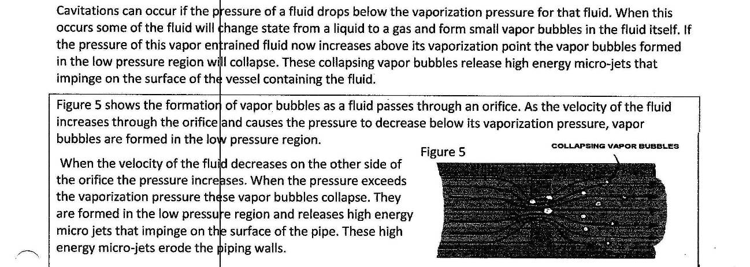
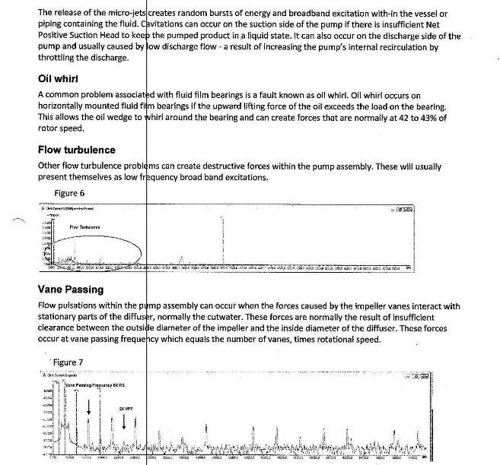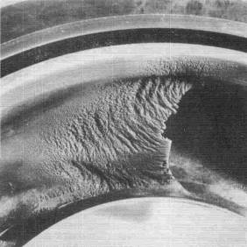

8. Mechanical seals versus packings
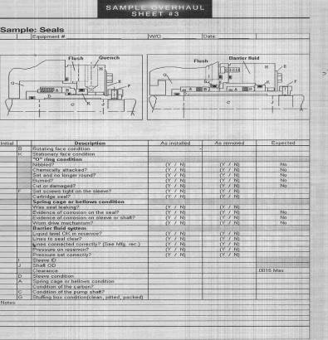

9. Materials of construction to combat various issues

Good design practice, suggests that where two parts contact, one part is explicitly chosen as the
sacrificial element. In a pump the sacrificial element is normally the stationary one. Typically
the rotating part is much more expensive to repair and much more sensitive to wear (balance
issues for example).
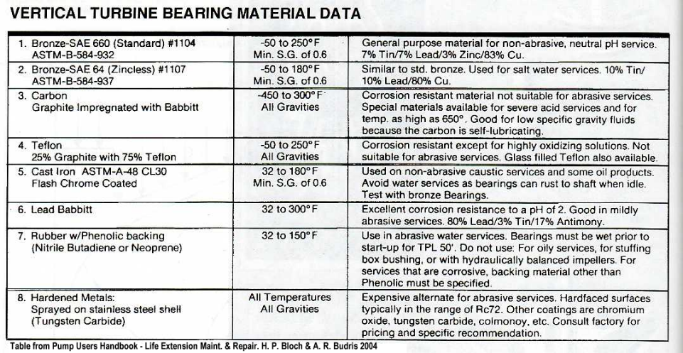
- Replacement of mechanical seals.
- Restoring clearances between impeller(s) and case liner(s) See Vertical Turbine Pumps fits and clearance checklist above.
- Epoxy coat impeller, bowls and piping. Epoxy coatings can be applied to extend the life of components that are exposed to heavy erosion or severe cavitation. Synthetic compounds such as Belzona® 1311 (Ceramic R-Metal), have been found to extend the life of the components until a new components is obtained or a solution to the pumping problem is found.
Many materials have been used for pump bushings and wear parts. Essentially any material that:

1. is chemically compatible with the pumpage,
2. can withstand the pumpage mechanically (abrasive wear or erosion for example), and
3. Is strong enough to resist the movement of the rotating part.
can serve as a wear part as long as a fluid film is maintained on the surface.

When the fluid film is lost, things get more interesting. Common metal materials are bronzes (of many types), hardenable alloys, stainless steels and carbides (silicon carbide, tungsten carbide, etc.). A differential hardness is usually specified
between similar metals on the rotating and stationary parts to resist galling on during the inevitable contact. For the hardest materials, harder shafts or shaft coatings must be specified.

Solving chemical and mechanical issues by selecting a more compatible metal part is a good
place to begin.

Rubber bearings are very common in a wide variety of applications. If they are kept lubricated and the application can handle the very large clearances, rubber can be an excellent choice. Graphite and Graphite/Metal materials have been used in pumps for decades. The key advantage of these materials is that there is no possibility of galling and little possibility of seizing. These materials can be run dry for very long periods without problems. Liquid gases, light hydrocarbons, condensate and deep well water are typical applications. Properly designed, tight clearances can be tolerated that help stability and may increase efficiency and reduce reticulation and NPSH. Graphalloy is one brand name for these materials.

Plastics cover a very wide range. PEEK and VESPEL are currently much discussed but other materials including Nylons, Teflon have their uses. While plastics are also non-galling, their temperature limits are lower. Many of these materials offer short-term dry running. Most plastics are insulators, and if run without lubrication, the heat generated is trapped in the bushing. This heat can build up rapidly causing expansion and possibly seizing the shaft. The carbon fibers in some of these materials can be extremely abrasive and may require hardened mating surfaces.

11. Motors, VFD, and electrical aspects

- Background:
  - Pump motors systems include vertical hollow shaft motors (VHSM) which are often are operated electronic controllers known in the industry as inverters, drives, variable speed drives, variable frequency drives, adjustable speed drives and other names but they typically control the motor by changing the speed with which the motor is operated to gain the most efficient system performance.
    - Allow control of the pump’s speed
    - Save energy by operating the pump at only the required speed.
    - Maintenance issues:
      - Vertical Hollow Shaft Motors (VHSM) operating on a Pulse Width Modulation (PWM) variable frequency drive (VFD) can have some unique bearing maintenance issues
      - Common mode voltage which is parasitically coupled to the motor’s shaft and can discharge in the motors’ bearings.
      - VFD can create a condition in the motor known as high frequency circulating currents (HFCC) in motors over 100 HP (75 kW) which may circulate through the motors frame to the bearings and the shaft.
    - Inverter rated windings and insulation:
      - Capable of resisting potential arcing between the windings in the stator.
      - Short circuits are possible from the extremely fast voltage rise times in the VFD’s pulses supplied to the motor.
      - This insulation is designated Class F or H by the NEMA MG1 Part 31 standard.
  - Whenever a new motor is purchased and installed or a motor is repaired both the bearings and windings must be protected from the VFD’s PWM pulses.
  - Electrical motor repair, bearing inspection, and testing must incorporate practices which prevent premature motor failure whenever possible.
  - Best practices in motor repair and analysis techniques will drive improved operations and decrease maintenance and the life cycle cost of the VHSM.

- Best Practices and Service Portfolio:
  - Assess motors with shaft voltage testing when operated on variable frequency drives.
  - Ensure that best practices are followed for bearing protection during the repair.
  - Give advice on preventing bearing failures for VFD driven motors.
  - Inspect bearings for signs of electrical discharge machining (EDM) damage
  - Satisfy the customer with superior repair services

- Best Practices: The best practices in this standard are intended to supply VHSM and pump operators and maintenance technicians in protecting motors operated by variable frequency drives (VFD) and establish bearing protection standards for new motor designs.
  - Any recommended repair practice or mitigation technology must have the following characteristics:
    - Long service life
    - Minimal maintenance requirements
    - Cost effective implementation
    - Proven performance
  - Motor Windings:
    - Specify the correct inverter rated insulation and wire to minimize possible corona arcing by using motors with minimum class F or class H insulation.
    - Review the system requirements to ensure the correct insulation rating is selected
    - In motor repairs specify class H insulation – a common specification in any motor rewind.
  - Motor Bearings:
    - Adding shaft grounding ring technology to any new motor or motor repair for VFD driven motors is the best practice in order to protect bearings from capacitively induced shaft voltages and the resulting bearing currents.
    - In addition to shaft grounding, motors above 100 HP (75kW) should have the opposite bearing isolated to prevent high frequency circulating currents.
    - When the recommendations are followed as part of the best repair practices, operators may be assured that their motors are repaired to the highest standards of service and reliability.

- ANSI/EASA Standard AR100-2010 and Shaft Grounding Best practices:
  - Will keep their motors operating in peak condition
  - Operations and facilities engineers and managers count on the motor service and repair shop to keep abreast of the latest technology and best practices.
  - Circumferential shaft grounding ring technology, proven in installations worldwide, is designed specifically for VFD induced bearing currents.
  - Bearing Inspection Reports: Cutting and inspecting every bearing in motors that come in for repair, especially when the motor is operated on a variable frequency drive, will often provide vital information needed to make the best repair recommendations. Detection of electrical discharge machining pits or fluting in the bearings often requires repair services referred to in this standard.
  - Installing a circumferential shaft grounding ring for an internal mounting inside the VHSM is the best practice solution in these systems.
  - For VHSMs over 100 HP (75 kW) requires isolating a motor bearing with an insulated sleeve; coating bearing housing with insulating material; adding a hybrid ceramic ball bearing or ceramic coated bearing and should be part of any motor repair or installed on new motors.
  - Testing and Analysis for VHSM or any motor operated on variable frequency drives improves system reliability and uptime. Services can include vibration analysis, thermography is best accomplished:
    - At the plant or facility while the motor is operating
    - At initial startup to detect shaft voltages and prevent possible future problems
    - After the motor is repaired with circumferential shaft grounding rings to verify their effectiveness
    - Periodically as part of a preventative maintenance program

- Electric Motors Operating on Line Voltage compared to VFD
  - Motors operated on line voltage from the power grid:
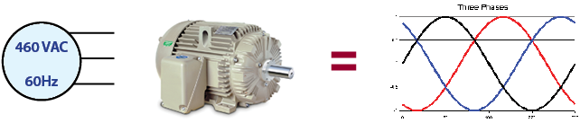
    - Line operations frequency is a sinusoidal 50 or 60 Hertz analog sine wave
    - Alternating current voltages are:
      - Low voltage <600 VAC
      - Medium/High voltage >600 VAC
    - Electric induction motors are designed for operation on 3 phase sine wave where the input power is balanced in frequency, phase (120 degree phase shift) and in amplitude.
    - Common mode voltage in a balanced system such as this means that the sum of the 3 phases always equal zero volts when properly balanced.
    - Bearing protection is generally not needed except for large frame motors.

  - Electric Motors Operated by Variable Frequency Drives (VFD)
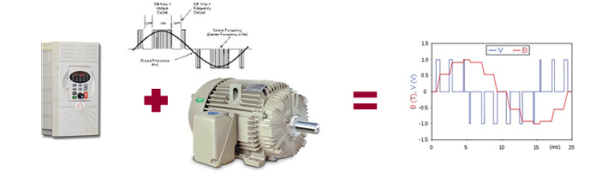
    - When operated by VFD, the power to the motor is a series of positive and negative pulses instead of a smooth sine wave.
    - The input voltage is never balanced because the voltage is either 0 volts, positive, or negative with rapid switching between pulses in all three phases.
    - The common mode voltage is usually a “square wave” or “6 step” voltage wave form.
    - In an unbalanced voltage condition Bearing protection needed to mitigate electrical discharge machining (EDM) damage in bearings.

- There are two primary sources of bearing currents in VFD driven VHSMs:

  - Bearing Current A:
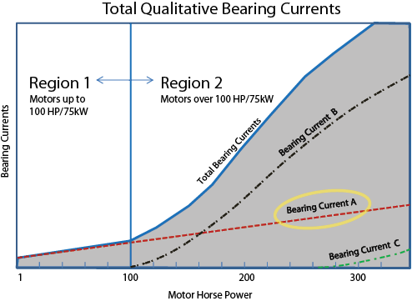
    - A capacitive induced shaft voltage that discharges in the motor bearings.
    - The VFD induced shaft voltages are capacitively coupled from stator to rotor through parasitic capacitance and create the possibility of bearing currents.
    - Virtually any motor from fractional HP to large motors may have bearing currents from this source.
    - Voltages can discharge through the motor bearings resulting in EDM pitting and fluting failure.
    - Best Practice:
      - Ground the motor shaft with a circumferential shaft grounding ring to discharge the shaft voltages reliably to ground.
      - The shaft grounding ring provides a path of least resistance to ground and diverts current away from the motor’s bearings.
      - Ref: NEMA MG1 Part 31.4.4.3
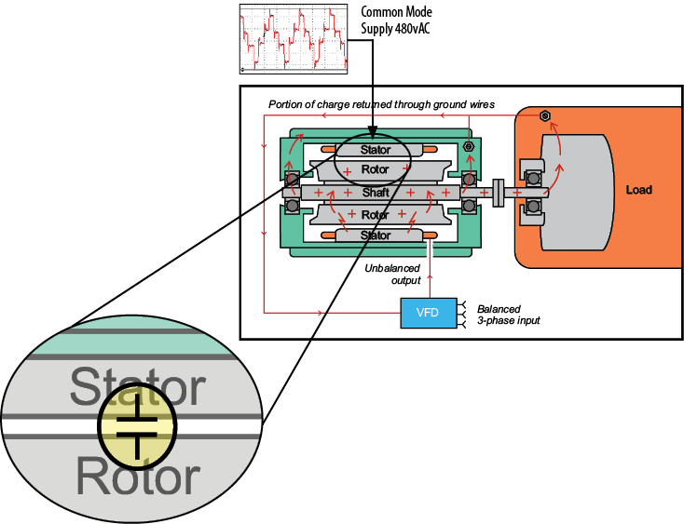
    - Why Bearing Current A exists in a VFD driven motor
      - An Electric Motor works like a Capacitor
      - The pulses to the motor from the VFD create a capacitively coupled common mode voltage on the motor shaft.
      - Voltages are measurable with a high speed oscilloscope and Shaft Voltage (SVP) Probe Tip.
      - Creates electrical bearing discharge currents.
- Voltage arcs through the bearing electrical discharge machining (EDM) creates thousands of pits in the bearing rolling element and race
- Bearings degrade, resulting in increased friction and noise
- Eventually, the rolling elements can cause fluting damage to the bearing races
- Bearing lubrication/grease deteriorates, is burnt and fails
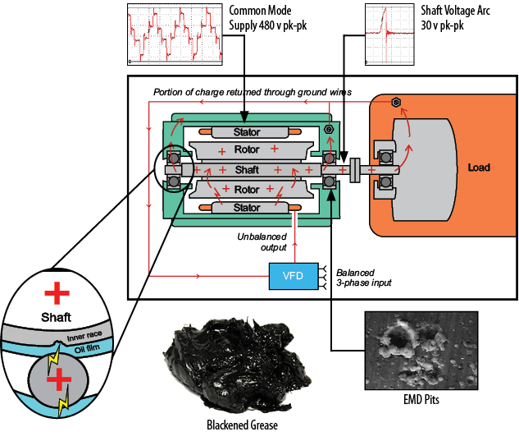
  - Bearing Current B:
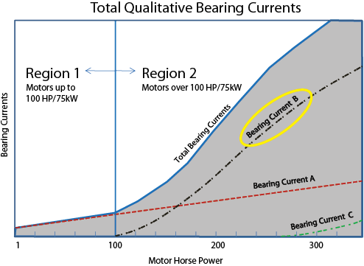
    - High frequency circulating currents may flow due to a high-frequency flux produced by common-mode currents. High frequency inductive circulating currents from VFDs are in the KHz or MHz frequencies.
    - Potential for costly unplanned downtime High Frequency Circulating Currents
      - May be present in motors above 100 HP.
      - Circulate through the motor bearings, shaft to frame.
      - Best Practice: Interrupting the high frequency circulating current in the bearing is the best approach to mitigating potential bearing damage. Also, motors subject to Current B (high frequency circulating currents) will also be subject to Current A (capacitively induced shaft voltage) and therefore need a circumferential shaft grounding ring.

- Best practices for bearing protection of VFD operation of VHSM
  - VHS Motors up to and including 100 HP (75 kW)
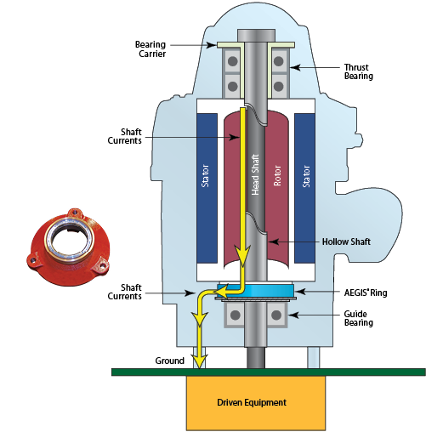
    - Bearing Current A
    - Requires circumferential shaft grounding ring
    - Install on DE or NDE
  - VHS Motors over 100 HP (75 kW) to 500 HP, Low Voltage up to 600 volts AC
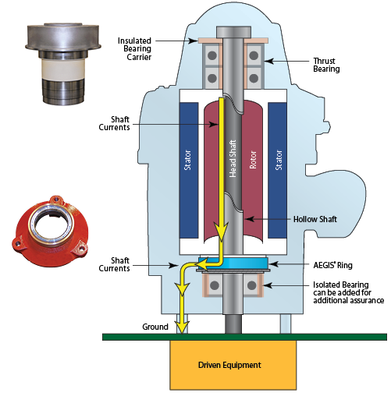
    - Bearing Current A & B
    - Requires circumferential shaft grounding ring usually DE
    - Isolate the upper thrust bearing with an insulate bearing carrier to break the circulating current path
  - VHS Motors over 500 HP, Low Voltage up to 600 volts AC
    - Bearing Current A & B
    - Requires HIGH CURRENT capable circumferential shaft grounding ring usually DE
    - Isolate the upper thrust bearing with an insulate bearing carrier to break the circulating current path
  - VHS Motors Medium/High Voltage over 600 volts AC
    - Bearing Current A & B
    - Requires HIGH CURRENT capable circumferential shaft grounding ring usually DE
    - Isolate the upper thrust bearing with an insulate bearing carrier to break the circulating current path

- Description of EDM Electrical Discharge Machining:
  - Because of the high-speed switching frequencies in PWM inverters, variable frequency drives induce shaft currents in AC motors. The switching frequencies of insulated-gate bipolar transistors (IGBT) used in these drives produce voltages on the motor shaft during normal operation through parasitic capacitance between the stator and rotor. These voltages, which can register 10-40 volts peak, are easily measured by touching an oscilloscope probe to the shaft while the motor is running. Reference: NEMA MG1 Section 31.4.4.3
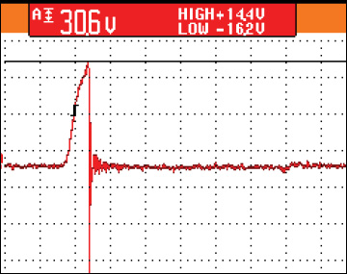
  - Bearing Frosting & Fluting - once these voltages reach a level sufficient to overcome the dielectric properties of the bearing grease, they discharge along the path of least resistance — typically the motor bearings — to the motor housing. During virtually every VFD switching cycle, induced shaft voltage discharges from the motor shaft to the frame via the bearings, leaving a small fusion crater (fret) in the bearing race. When this event happens, temperatures are hot enough to melt bearing steel and severely damage the bearing lubrication.
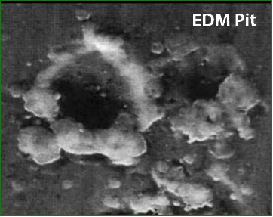
  - Bearing discharges - these discharges are so frequent (millions per hour) that before long the entire bearing race becomes marked with countless pits known as frosting. A phenomenon known as fluting may occur as well, producing washboard-like ridges across the frosted bearing race. Fluting causes excessive noise and vibration and in heating, ventilation, and air-conditioning systems, it is magnified and transmitted by the ducting. Regardless of the type of bearing or race damage that occurs, the resulting motor failure often costs many thousands or even tens of thousands of dollars in downtime and lost production.
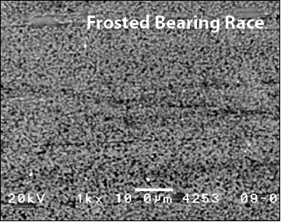
  - Failure rates vary widely depending on many factors, but evidence suggests that a significant portion of failures occur only 3 to 12 months after system startup. Because many of today’s AC motors have sealed bearings to keep out dirt and other contaminants, electrical damage has become the most common cause of bearing failure in AC motors with VFDs.
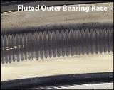

- Bearing Inspection in VHSMs when they require repair:
  - Cutting and inspecting every bearing in motors that come in for repair, especially motors operated on variable frequency drives, will often provide vital information to make the best repair recommendation and improve performance.
  - Inspect the bearing and bearing cavity and retain a sample of the lubricant if further analysis is warranted.
  - Look for:
    - Contamination
    - Signs of excessive heat
    - Hardening of grease
    - Abnormal coloration (blackened grease)
    - Excess grease escaping the bearing
  - Cut the outer race into halves.
    - Follow established safety precautions and use personal protective equipment including eye protection, hearing protection, face shield, gloves and protective clothing.
    - Inspect the grease and contamination in the bearing.
    - Burnt Grease: Continuous electrical arcing in the motor bearings will often rapidly deteriorate the lubricating capability of the grease and cause bearing race damage. When an arc occurs, the oil component of the grease is heated beyond its temperature capacity.
    - Contamination: In addition to the burnt grease, the arcing causes small metal particles to loosen from the bearing races/balls which are distributed in the grease. These particles are abrasive and intensify the bearing wear.

- Burnt bearing grease and deterioration of lubrication
  - Grease burns from the arcing and is blackened and often times contaminated with carbon and metal particles.
    - New bearing grease is available in many colors such as blue, brown, or grey.
  - Clean the bearing’s components using a degreaser or solvent.
    - Follow all safety precautions.
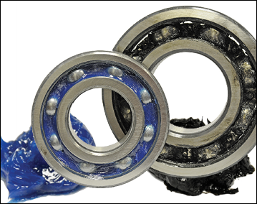
  - Inspect for evidence of Electrical Discharge Machining (EDM):
    - EDM are millions of microscopic electrical pits created when current discharges through the motor’s bearings.
    - The electrical voltage overcomes the dielectric of the bearing lubrication and instantaneously arcs through the inner race, through the ball and to the outer race.
    - The individual pit is usually between 5 and 10 micron diameter.
  - Frosting:
    - This will appear to be a grey discolored line around all or part of the bearing race and may be evident in the inner and outer race.
    - The discoloration may be caused by wear or by electrical EDM.
    - Examination under a microscope may be required to determine if the line is EDM or not. If the motor was operated on a VFD with no bearing protection there is a high likelihood that the frosting is from EDM.
  - Fluting Damage:
    - Identified by a distinctive washboard pattern.
    - Fluting can be identified with the naked eye or with 10x magnification.
    - Fluting is sometimes confused with mechanical bearing damage so care should be taken to correctly assign electrical fluting damage to the pattern observed.
  - Cutting and Inspecting a Bearing
    - In addition to using this manual please refer to other bearing failure analysis experts in order to determine the root cause of failure.

- Grounding the Motor Shaft:
  - The circumferential shaft grounding ring conducts harmful shaft voltages away from the bearings to ground.
  - Voltage travels from the shaft , through the conductive microfibers, through the housing of the ring, through the hardware (or conductive epoxy) used to attach the ring to the motor, to ground.
  - All paths must be conductive.
  - Any paint or other non-conductive surface must be removed to ensure a conductive path to ground.
  - Clean all fits within the conductive path
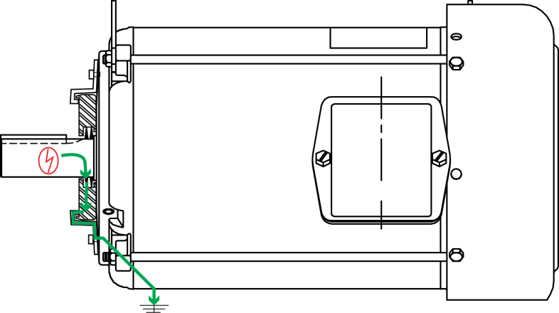

- Shaft Preparation for Internal Installation
  - The circumferential shaft grounding ring should not operate over a keyway because the edges are very sharp.
  - For proper performance adjust or change spacer and screw lengths to avoid the keyway
  - Fill the keyway (in the area where the shaft grounding ring is located with a fast-curing epoxy putty
  - Motor shaft must be conductive:
    - Shaft must be clean and free of any coatings, paint, or other nonconductive material (clean to bare metal).
    - Depending on the condition of the shaft, it may require using emery cloth or fine grit sandpaper (220 grit is recommended).
    - If the shaft is visibly clean, a non-petroleum based solvent may be used to remove any residue. If possible, check the conductivity of the shaft using an ohm meter.
  - Ohms test:
    - Place the positive and negative meter leads on the shaft at a place where the microfibers will contact the shaft. Each motor will have a different reading but in general you should have a maximum reading of less than 2 ohms. If the reading is higher, clean the shaft again and retest.
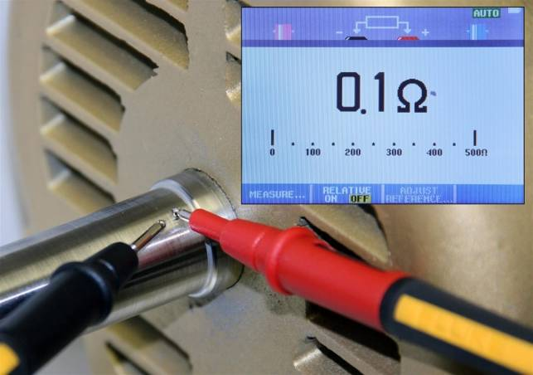

- Circumferential shaft grounding ring installation
  - Install the shaft grounding ring so that the aluminum frame maintains an even clearance around the shaft. The conductive microfibers must be in contact with conductive metal surface of the shaft.
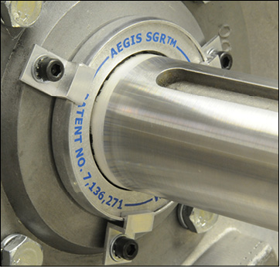
  - Colloidal Silver Shaft Coating is recommended for all applications.
    - The silver coating enhances the conductivity of the shaft and also lessens the amount of corrosion that can impede the grounding path.
    - Treating the shaft of the motor prior to installing the shaft grounding ring
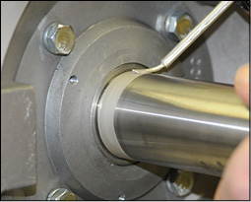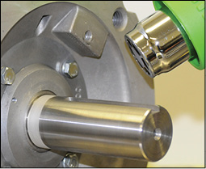

- Low Voltage Shaft Grounding Ring:
  - For motors with supply voltage <600 VAC and <500 HP
    - Design Type: CIRCUMFERENCIAL SHAFT GROUNDING RING
    - Circumferential conductive micro fiber rows in a protective channel to allow sufficient flexibility.
    - Rows of fiber: 2
    - Fiber overlaps shaft 0.030” (.76mm)
    - OAL: 0.295” (7.5mm)
    - Internally mounted to motor bearing bracket
    - Motors over 100 HP - recommend isolation of thrust bearing and shaft grounding ring on lower bearing.
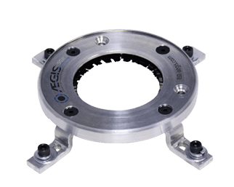

- High current capable circumferential shaft grounding ring
  - Supply voltage greater than 600 VAC
  - Motor over 500 HP
    - Design Type: CIRCUMFERENCIAL SHAFT GROUNDING RING – High current capable
    - Circumferential conductive micro fiber rows in a protective channel to allow sufficient flexibility.
    - Rows of fibers: 6
    - Fiber overlaps shaft 0.030” (.76mm)
    - OAL: 0.625” (15.875mm)
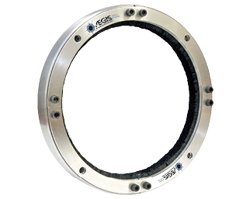

- Mounting:
  - Internal mounting to the lower bearing retainer bracket
  - Shaft grounding ring select based on shaft diameter
  - Press Fit Installation into bearing retainer bracket:
  - Bore Specification: 0.002” – 0.004” interference [.05 mm - .10 mm]
  - Custom Bracket may be added to rise the SGR above the grease level
  - A lip seal should be incorporated into the bracket to prevent grease from migrating up to the shaft grounding ring
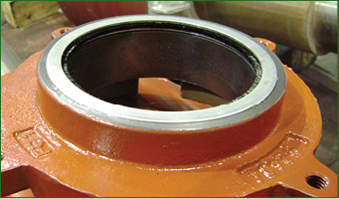

- For external installation:
  - The shaft grounding ring must run on the motor or pump shaft at the lower bearing.
  - The ring must not be mounted around the steady bushing.
  - Upper bearing may be isolated with insulated bearing carrier for added protection on any VHSM.

- Maintenance free shaft grounding ring technology description:
  - Design must be a 360 degrees circumferential conductive micro fiber ring.
  - Conductive micro fiber rings have minimal ultra low friction to the motor shaft
  - Circumferential shaft grounding rings provide both contact and noncontact grounding called Nanogap Technology
    - Unique contact/non-contact design
    - Multiple row design – greatest reliability
    - Ensures unmatched shaft grounding and performance
    - Ensures effective electrical contact even when physical contact is broken .
    - Provides both maintenance-free contact and noncontact bearing protection for the normal service life of the motor’s bearings.
    - Rings must be designed so that microfibers flex without breaking
    - Fibers must be secured in a protective channel

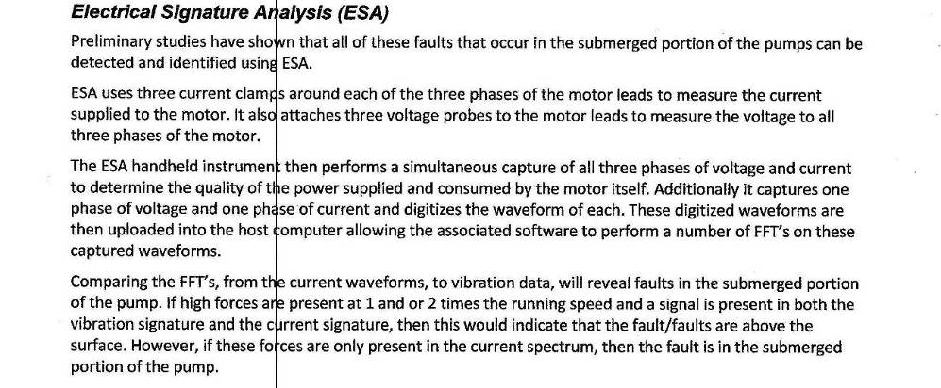

12. REFERENCES and Bibliography
A. Hydraulic Institute
B. PIP Practices
C. API-610
1 = “Repair Standard for Vertical Pumps”, Pumps & Systems, February 2012, pp. 16-17
2 = “Vertical Turbine Pump Reliability”, P&S, March 2010, pp. 16-19
3 = “The Downside of Perfection in Vertical Turbine Pumps Repair”, P&S, May 2009, pp. 8-9
4 = “Finding the Root Cause of Failure”, P&S, April 2009, pp. 10-11
5 = “Repair, Overhaul and Upgrade of Vertical Turbine Pumps”, P&S, January 2008, pp. 14-16
6 = “Repair and Upgrade of Multistage Centrifugal Pumps”, P&S, December 16-17, 2007

