
PUMPING MACHINERY, LLC * 2977 Four Oaks Drive * Atlanta, GA 30360
Tel. 770-310-0866 * Fax 770-350-9311
Email DrPump@PumpingMachinery.com * Web www.PumpingMachinery.com

Limited Study of the Electro-Magnetic Effects on Several Substances

Project MBP rev.2
(molded bread and paramecium)

Report #020414-2
Date: February 10, 2014
by
Dr. Lev Nelik, P.E.
PML Company

Executive Summary
The project was initiated as a limited scope study of the effects of electro-magnetic energy on various substances, as prompted by the numerous internet-published claims of successes of so-called Rife technology, and/or applications similar (with various modifications) to Rife technology. Some of the background of this work is presented at:

www.pump-magazine.com/pump_magazine/editorial/editorial.htm

Our limited research project claims no known, real or perceived, applicational benefits or useful effects of these experiments, and have conducted this work primarily out of an engineering curiosity and as a hobby, motivated by what we saw published on the internet by the Rife technology enthusiasts, with most of the data presented unfortunately as anecdotal.

The main two experiments we conducted were:

a. Molded Bread test and
b. Paramecium test

It is the basic belief of our research team involved in the project, that any substantial scientific claim(s), to have any credence, must be:

a. well documented
b. verifiable and
c. repeatable

Essentially none of the reported Rife-related work available on internet meets these three criteria, and constitutes mostly a mixture of hearsays, rumors and wild claims, with no proper description of the detailed manner of the experiments, and no references available to interview as far as the factual success of the technology. Numerous lists of “effective” frequencies remain in conflict of each other, with no systematic cataloguing of what works and what does not. The best known reference available is “The Rife Machine Report”, by Jeff Garff, which while presenting an excellent 200+ page summary of history, contains unclear conclusions and erroneous charts, for example misread power levels of spectral charts, and no referenced actual success cases that could be replicated today by any independent researcher. Other references are available via the above noted web link.

Given the confused state of the art, to say the least, present project was an attempt to evaluate the effectiveness of electro-magnetic method on at least two simplest cases: to suppress the growth of mold on bread, and kill a simple single-cell organism (paramecium). Should the success of either test were to be found, a starting believability basis could be established for at least a potential possibility of similar beneficial effects on more complex organisms, as these internet Rife researcher claim. Conversely, a failure to produce positive results on at least these two very simple tests would likewise mean a future experimentation with more complex organisms would be meaningless, and thus the claims of successes doubtful.

The two conducted tests are documented in this report, with as much detail as possible. Instrumentation, frequencies, distances, temperatures, and other parameters, were used and applied from the best known internet-published reports by various claimants of the Rife technology. However, due to a very limited details available, our project team had to follow a somewhat obscure path of documentation, and a reader may find the project lacking some important details, or modifications and corrections required to rectify such inadvertent errors we might have made. Should better suggestions on instrumentation used, times of exposure, temperatures, distances, or any other factors, come forward as available, we would gladly correct the errors, and redo the experiments, to follow any specific suggestions or recommendations, as long as these suggestors can present positive and verifiable results in their facility(ies), and thus replicable by any other independent interested researchers.

Furthermore, any interested researchers who would like to visit our laboratory, and help make any necessarily corrections and adjustments to make the experiment more accurate or better, are welcome to do so, by contacting us at any time and schedule the visit to make the suggested modification and repeat or redo the experiments, which typically should not take excessive time, especially for the researchers with as much luck and success as they claim.

Instrumentation used in this project

Fig. 1 is a schematic of the instrumentation. As illustrated, an audio signal was generated by the laptop computer and sent to a CB RF radio via a push-handle, where is was modulated by the 27.125 MHZ, and forwarded via amplifier and balancer to the plasma tube antenna. The frequency range of the audio signal is described further below. In addition, two other commercially available UVC tubes were also applied (in separate tests), as well as one commercially available Rife technology device, manufacturer by Deta-Elis company. The applied targets were molded bread, and paramecium, as described below.
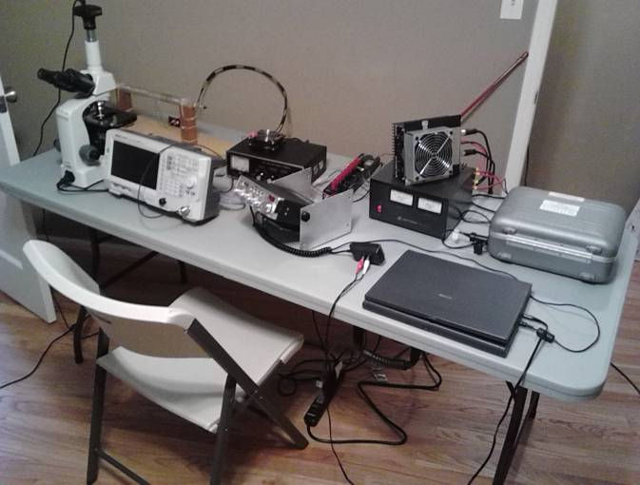
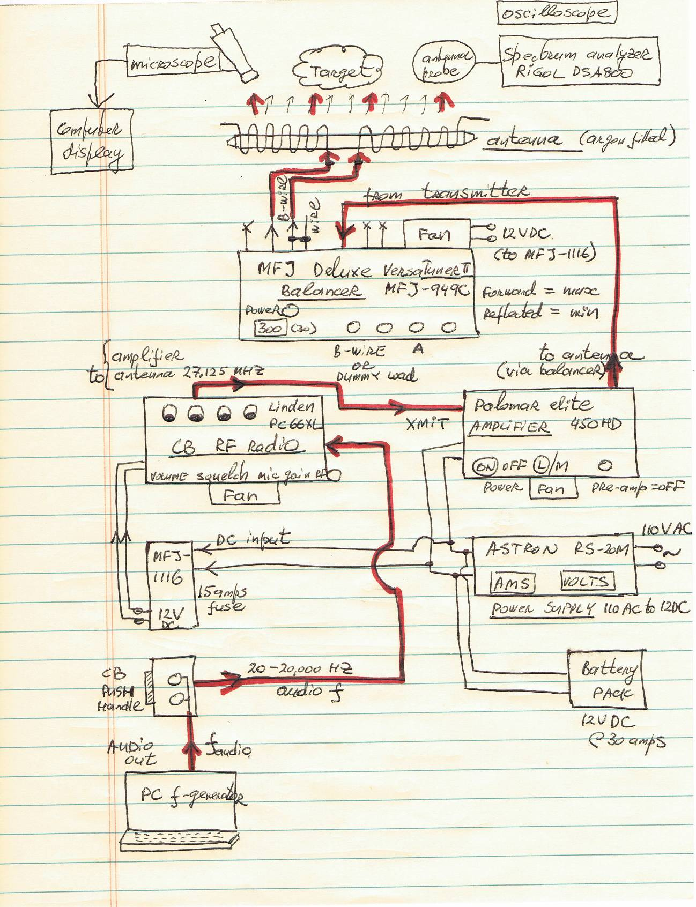
Fig. 1 Instrumentation used – overall view and diagram

Molded Bread Tests
(4) types tests were conducted:

A. Direct exposure under the large UVC tube, with no connection to the instrumentation:
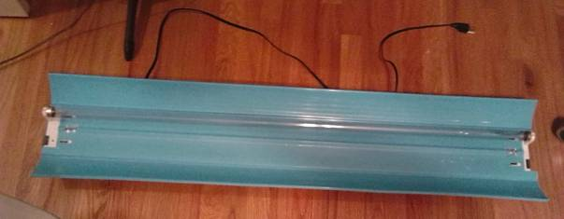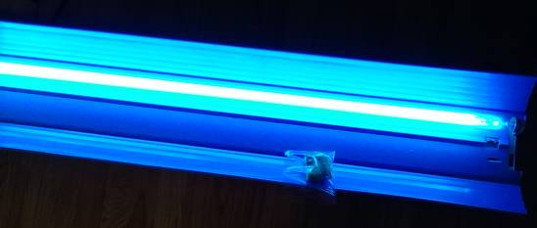
Fig. 2A Standard commercially available 80 watts UVC tube (large size)

B. Direct exposure under the small UVC tube, with no connection to the
instrumentation:
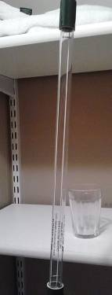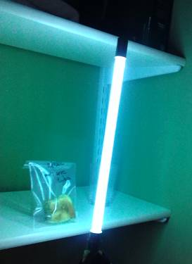
Fig. 2B Standard commercially available 40 watts UVC tube (small size)

C. Plasma tube – with no obstructions between it and bread
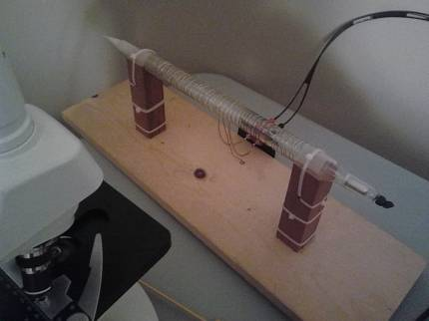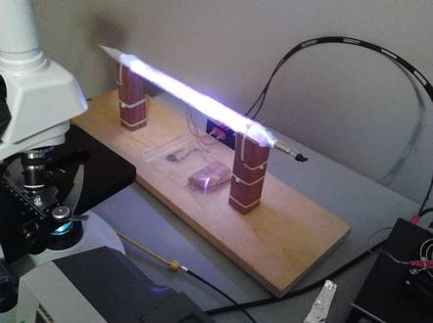
Fig. 2C Wire wound argon filled plasma UVC tube (used with no cover)

D. Plasma tube – covered by the box, thus filtering out any UV radiation
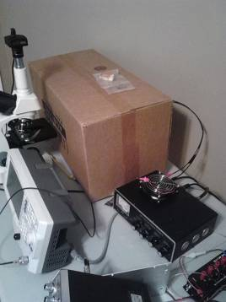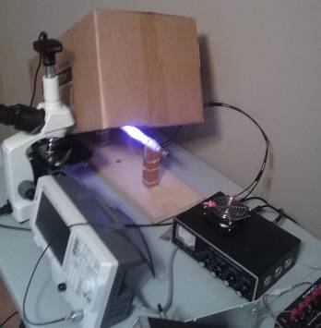
Fig. 2D Wire wound argon filled plasma UVC tube (used with cover; shown partially exposed on the right photo for illustration)

Molded Bread Tests – results:
The tests were conducted similar to as described in the article by Audrey Scoon. The piece of natural bread (no preservatives) was moistened and left out overnight. It was then cut into 4 pieces and enclosed into a zip-locked packets. A control sample was saved off at the off-site location. The other three pieces were exposed to correspondingly small, large, and plasma tubes, as described above. Exposure was for approximately 30 minutes, at approximately 6 inches distance from the tubes. Plasma tube had audio frequencies (pulsed) scanned from 1000 Hz to 2900 Hz during that time, in steps of 10 Hz (1000, 1010, 1020, etc.), for 10 seconds exposure at each frequency. The carrier frequency was 27.125 MHz, as noted at the instrumentation description section. Temperature of the environment was ambient, approximately 70-75 deg. F.

The packets were observed for over a week. Mold appeared on all pieces after approximately 3 days, and continued to develop, essentially with no perceptible differences in all 4 packets:

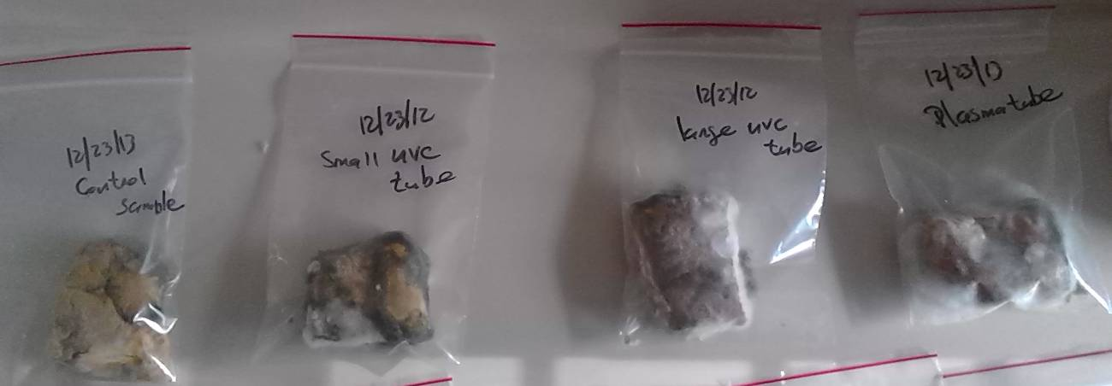
Fig. 3A: molded bred experiment #1

The tests were then repeated, with the addition of the enclosed plasma tube under the cardboard box, to prevent UV light, and thus separating the UVC radiation effects from audio modulated EMC energy.

As Fig. 3B shows, the results were essentially the same as in the first experiment – i.e. mold developed on all pieces:

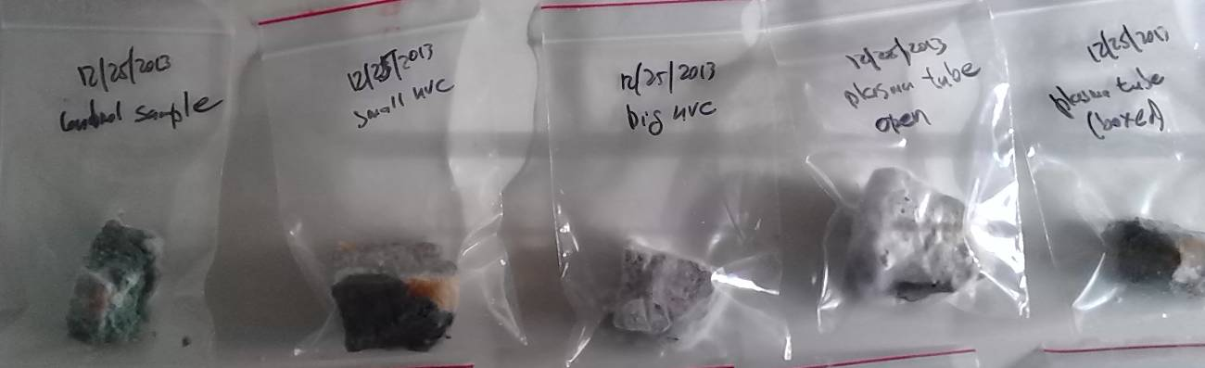
Fig. 3B: molded bred experiment #2

The third test was similar to the second, but on a treated (commercially available at the store) bread. None of the samples developed any mold:

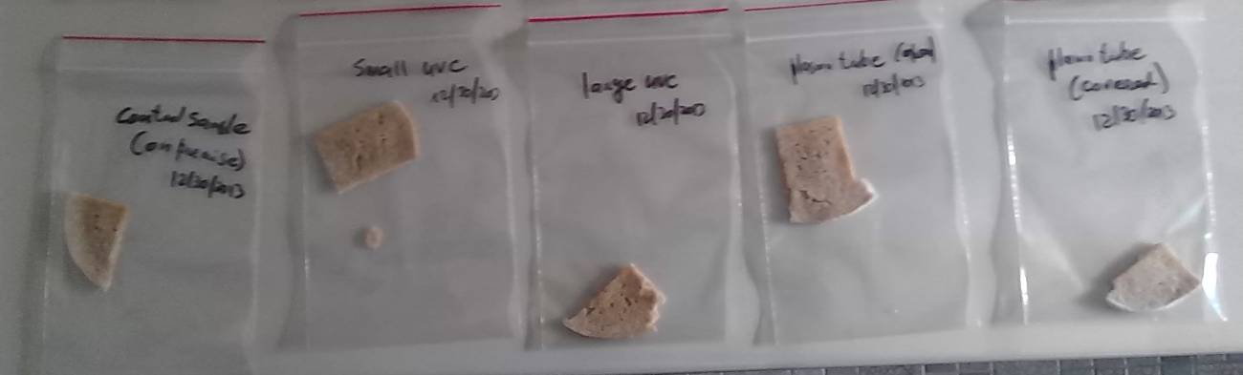
Fig. 3C: molded bread experiment #3

Discussion on bread mold tests
From the tests conducted, no affect by the EMC energy was observed, regardless if the sample was directly exposed or covered under the cardboard box. Several reasons for this can be considered:

a. Zip locked packets did not seal sufficiently hermetically, allowing new mold spores to gradually enter, after the treatment
b. Energy levels were too low
c. Applied frequencies were incorrect – either audio, carrier, or both. Shape of the signal wave (pulse versus sine, versus other) are incorrect
D. The Rife technology does not have affect on this
E. Other reasons (concrete suggestions are welcome)

Paramecium Tests
These tests were conducted in response to the video shown on the YouTube, claimed to having been conducted by Deta Elis company, to demonstrate the effectiveness of Rife technology applied at the Deta-Elis (Russia) machines:
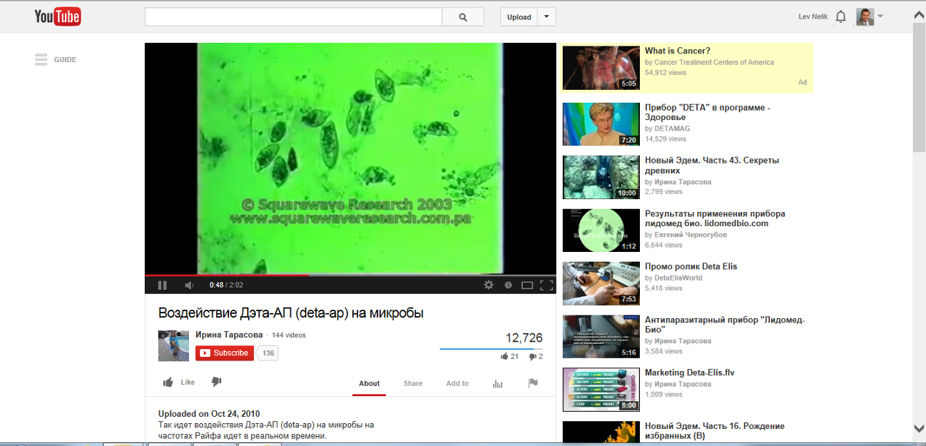
www.youtube.com/watch?v=Czy1EMHO2hk (the title under video says in Russian: Effect of Deta-AP on microbes)

However, we have contacted the SquareWave Research company, whose logo is displayed over the video. SquareWave company is based not in Russia, but in San Diego, California (apparently a small consulting lab), and they told us this video was indeed made by SquareWave per request of a US Rife practitioner, and the tests were conducted not by the application of the EMC energy, but by a direct current at 0.25 Volts through the Petri dish saline solution medium with paramecium in it.

We have attempted to re-construct such electrode-based device, as shown on Fig. 4, and at least replicate the SquareWave experiment, applying the 1150 Hz (and also another test at 3900) Hz current frequency (also with several steps of +/- 10 Hz sets on both sides of these) and 0.25 voltage monitored by the oscilloscope. Unfortunately, there was no effect on paramecium, and they continued swimming around and vigorously, essentially non-affected:

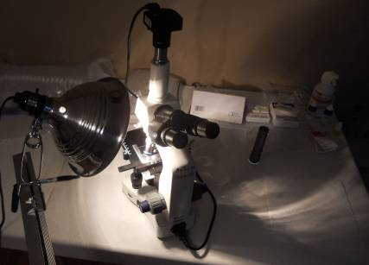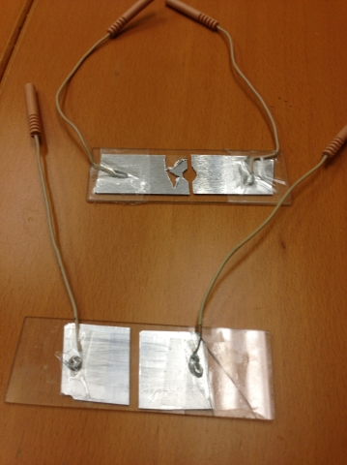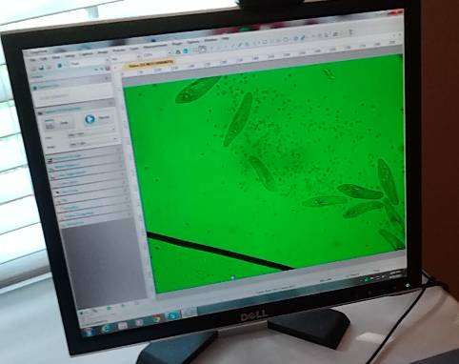
Fig. 4 Electric current thru the water with paramecium

In discussing our inability to affect the paramecium by the direct current, Squarewave commented that the solution needs to have sufficient salinity, while our sample had tap water. We have asked SquareWave to help us with setting up the experiment, on a consulting basis. SquareWave has not returned our calls since.

Heating up paramecium with light bulb

As shown on Fig.5, and www.youtube.com/watch?v=-XZeOCK10hc – by direct heat lamp energy, paramecium is affected and dies in a manner similar to shown at other YouTube videos. That happens when temperature reaches approximately 95deg. F (35 deg. C):

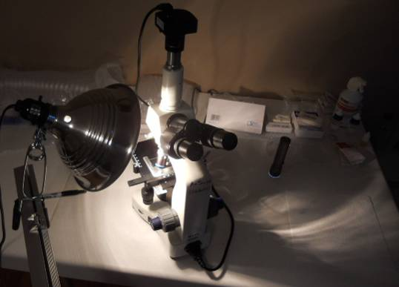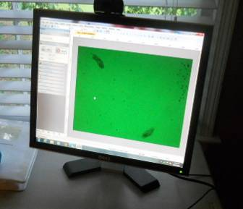
Fig. 5 Heating up paramecium with light bulb

Radiating paramecium with the Deta-Elis device
As shown on Fig.6, we applied several standard programs on the device we purchased from Deta-Elis. None affected paramecium in any way:

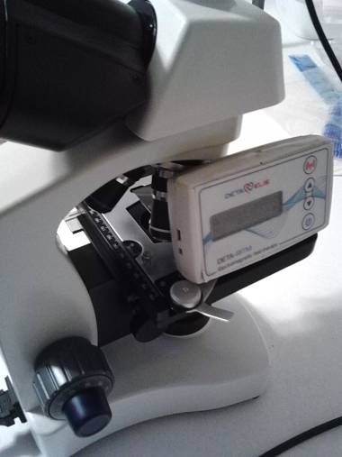
Fig. 6 Radiating paramecium with the Deta-Elis device

In discussing this with Deta Elis representatives, they told us that the organisms can be devitalized only in the “affected state”, but a fresh sample of such organisms, exposed to radiation by their device, would not, as they told us, work. In other words, Deta Elis claims their device works only on people, but the same organisms exposed to the device outside human body, will not be affected. With that, we have conclude our tests of the Deta Elis device, and have no plans to continue any other testing.

Summary and conclusions

1. Our limited tests with molded bread and paramecium resulted in no effect.

2. The above work is on a very limited scope and limited knowledge. Any additional input would be welcome, and anyone wishing to visit our lab and demonstrate the concrete results contrary to our finding is welcome to let us know, and we will gladly make plans to accommodate.

3. Rife technology appears to be an obscure dark room experimentation with no structure, with no or little proof of its effectiveness. The field appears to be dominated by the practitioners with either incomplete, incorrect, erroneous, or misleading information. None of those practicing we contacted were willing to replicate the tests, nor expressed interest to visit us, or us visit them, and to show factually where we possibly made mistakes or missed some important factor. The fundamentals of physics governing the so called Rife Technology does not appear to be clear to even more advanced, if there are such, practitioners of this field. Terms like modulation, harmonics, frequency, and others are used by the Rife enthusiasts sparingly and without true understanding what these are, and are mostly past from one enthusiast to another in anecdotal manner. None of these practitioners, for example, had clear understanding how a step pulse function generates harmonics, and essentially all of them are completely unclear of the difference between harmonics and sidebands, nor do they have any basic understanding of the energy conservation fundamentals, familiar to essentially any fist year college student of electronics, electrics, or mechanical engineering.

However, this is only a perception, and perhaps some factual information has escaped our search. If such documented and proven research indeed exists, we would be interested to learn more about it, and hopefully at that time be able to replicate it. Our objective was not to come up with the data no otherwise available, but rather find out, and if so replicate, the tests others have done proving the mold can be affected and paramecium can be devitalized, similar to what is shown on the video of the link above, which unfortunately turned out to be a misrepresentation.

This by no means should be viewed as disrespectful to many of those who truly believe, or at least hope to believe, that this technology works. Most of these people do not have a technical background to understand the complicated terms presented in unfortunately obscure or very new for them terms. Their desire to believe the technology works is understandable, and if by a strength of their conviction, factual or not, they choose to follow and apply this technology for their needs, - that is fine and good.

As in anything else, anyone that got cured by anything, without knowing why and how, placebo or a real thing, desires wholehearted support and congratulation that it works for them. We also understand and admire the efforts of earlier researchers in this area, including Dr. Rife himself, who genuinely wanted to develop something that does much good to a lot of people. Many years of work went into this, and such efforts are commendable and to be applauded. Many of those who followed, wanted earnestly to learn and document exactly what and how these earlier tested (alleged) achieved such wonderful reports, at least from the sketchy documentation they left behind. With the added confusion of others, less scrupulous and less knowledgeable practioners of this art, the true benefits that might have been gained, became covered by the layers of anecdotal shell or capitalized commercial interests, with little tribute to the true merit of presence, or absence, of technical evidence.

For us, however, the objective is simply to have factual and verifiable evidence that indeed this works, - or not. In either case, we would be happy to know the true facts, one way or another.

4. At the present time, we have no plans or interest to continue this research, as the results and findings appear to speak for themselves, and unfortunately not in a more positive way as we had wished. Should others come up with tests contrary to our findings, we would be glad to correct any errors in our procedures or details, and would welcome any tests with outcomes different from ours to demonstrate such in action, in their lab, or at our. Until some rhyme and scientific reason is applied with better rigor and diligence to this subject, the time is likely better spent elsewhere.

In summary, should a test affecting mold on bread, or devitalizing paramecium, become known and verifiable, we would welcome such news, visit the facility to see such test(s), and will try to replicate in our lab. We are not interested in anything more sensational, which has proven unverifiable. The proof to anything great needs to be first demonstrated in something less grandeur, but verifiable. Until such tests become available, we will remain waiting.

Sincerely,

Dr. Lev Nelik, P.E.
PML

References
* www.pump-magazine.com/pump_magazine/editorial/editorial.htm

FEEDBACK and Questions
We are posting feedback and/or questions from our readers below:

1. From: Chakravarthy Anbazhagan

California
Sent: Wednesday, May 07, 2014
To: DrPump@Pump-Magazine.com
Subject: DETA ELIS-AP Test

Hello Dr.Lev Nelik,

This has reference to the url : http://www.pump-magazine.com/pump_magazine/editorial/editorial.htm on your online pages regarding the tests that were carried out by you in association USTech on the DETA ELIS-AP and DETA ELIS-RITM bioresonance devices.
While the test reports of DETA ELIS-RITM are posted on
http://www.pump-magazine.com/pump_magazine/editorial
- those of DETA ELIS-AP devices are not found on the relevant hyperlink mentioned in your article.

This link takes us to http://www.pump-magazine.com/pump_magazine/editorial/PAPERS/papers.htm but nothing is available there.

Do you have the test report on this AP device with captured waveforms (both time and frequency domain) for different device program settings? If so please let me know where these are posted/located in order to get an idea of the device and evaluate it's usefulness etc.

Thanks in advance,
Best,
Chakra

Chakra - thank you for your comments; I have fixed the links you noted to AP and RITM results.

For papers, - click the individual links to each paper. The most current is our report, linked to the right as:


Our overall view of Rife technology is rather disappointing, which includes not just Deta but all others, as you might have seen from the report above. There appears to be a lot of marketing hoopla but essentially no solid technical data, and not even a single laboratory that would be willing to demonstrate to witness their results under the microscope at their lab, to see a proof of affecting a simple set of cells, such as paramecium for example. Until that becomes available, our interest has substantially receded.

Lev Nelik
PML

Lev,
Thanks for the prompt response and fixing those missing links in the mentioned article.
Regarding the Rife machines, yes your observations are very correct that these so called Rife technologies are more of hype than real worth. The real research, findings and developments by Raymond Rife and his followers of his time were excellent but over the years it has been distorted, modified and eroded as any one liked without proper scientific research and clinical validation. There are countless so called Rife frequencies available now with each claiming to cure a particular disease or condition wit out any scientific proof or experimental data or validation.
I am a MSEE and have over three decades of electronics systems design expertise having designed sophisticated systems for many multinationals over the years and have been interested in these Bioresonance technologies since many years now. I believe Rife's technology is true as I myself have designed few Bioresonance systems for my own experiments and in my view this technology needs to be further taken up seriously and scientifically researched and taken to a new level to benefit all of us.
Regarding the DETA-RITM device, these RITM devices work differently (based on RITM's original scenar technology) and are not meant to destroy the pathogens. They stimulate the body by generating the electrical neurological signals to cause a response similar to that caused by the brain when a healing takes place where generation of endorphins etc by the brain are involved.

We need to look at the time-domain signal for these devices which will be a 'delta' signal of certain amplitude and shape, repeated at varying low frequencies (in the range of 1Hz to 100 Hz). This signal would of course have many harmonics in the frequency domain and are not related to Rife frequencies. I had been using a similar Russian device since last few years.
The DETA-AP signal waveforms are surprising. It should be an RF carrier modulated signal where only the upper sideband might be in use. I suspect they have not given the correct specifications for the device and is probably guarded in secrecy. I believe most of their healing frequencies are very low frequencies modulated on the carrier and one needs proper techniques to capture and evaluate them.
I have all the basic lab tools including the oscilloscope etc but don't have these DETA devices so don't have much info about them.
The credibility of this company was always in doubt due to their MLM operation. It is interesting to know that this company was recently raided by the Russian authorities and all their assets seized and factory was forced to close. It looks like they have moved the manufacturing to Germany now. Let's see what happens in future.
Best,
Chakra
Chakra, - thanks again for your interesting and informative feedback. I agree with you. The original work Dr. Rife started many years ago seems like a very interesting and promising area. My own feeling is that, given proper attention to technical details, serious and verifiable testing conducted by a qualified research organization or several of such, with results presented at conferences attended and debated by medical, engineering, and other professionals, this could be a very valuable contribution to a development of something that one day could offer real and tangible benefits to the society. At the moment, however, this is not happening, and the field instead is dominated by the enthusiasts with neither no proper qualification, nor ability or desire to provide verifiable results in their facilities.

Best regards,

Lev Nelik
PML

